

**《数据库课程设计》**

**实验报告**

**实验名称： 物业公司管理系统**

**班 级： 智科Q191班**

**组 员： 万强 陈纪鸿**

**指导老师： 刘琴**

**日 期： 年 月 日**

**评阅成绩：**

**教师签名：**

目录

引 言 3

1数据库概念模型 3

1.1 需求分析 3

1.2 功能介绍： 3

1.3 概念结构设计 5

1.3.1抽象出实体 5

1.3.2整体E-R图 5

2数据库逻辑模型 5

2.1将E-R图转化为关系模式 5

3数据库物理设计与实施 6

3.1 创建数据库 6

3.2 基本表的创建与管理 6

3.3 插入数据 11

3.4访问数据库 12

4程序设计 13

4.1创建应用程序 13

4.2连接数据库 14

4.3设计应用程序 14

5测试用例 31

5.1 超级管理员测试 31

5.2 普通管理员测试 39

5.3 用户测试 40

6作业总结 42

附 录 42

数据库操作部分的Python代码 42

小组成员任务清单 71

# 引 言

物业公司管理系统

1. **背景资料**

（1）公司有很多个小区需要管理，每个小区都管理着许多用户。

（2）每个小区都有小区编号、小区名、小区地址等，每个用户都有自己的家庭编号、车辆编号等。

1. **基本要求**

能实现以下主要功能：

1：实现对小区、用户、员工的管理（添加、删除、更改、查找）。

2：实现对小区、用户、员工部分检索功能（如：只输入用户姓名就可以找出相应的用户信息）

3：可视化相应信息表格。

# 1数据库概念模型

## 需求分析

在现实生活中存在着许多用户与物业之间的矛盾，用户不能很好了解物业公司信息，所以很难享受物业管理带来的便利，物业公司也因为收集不到小区业主的相关信息不能很好的管理小区用户。归根结底是应为没有好的物业公司管理系统。开发这样一款管理系统可以解决物业与用户之间的信息不透明问题。有利于解决生活中两者的许多矛盾。

## 功能介绍：

**超级管理员：**

1）：实现对小区的添加，实现对小区信息的查询、添加、删除、更改。小区信息包括小区编号、小区地址、小区面积、开发商、小区宠物数量、小区住户数量、小区车辆数量、小区员工数量、小区楼栋数量、小区停车位数量、小区名

2）：实现对用户的添加，实现对用户信息的查询、添加、删除、更改。

用户信息包括：户主信息、家庭信息、宠物信息、车辆信息与停车位信息

3）：实现对员工的添加，实现对员工信息的查询、添加、删除、更改。

员工信息包括：员工编号、小区编号、职称、姓名、性别、年龄、电话、员工身份证号，薪资。

**普通管理员：**

1）：实现对小区信息的查询、添加、删除、更改。小区信息包括小区编号、小区地址、小区面积、开发商、小区宠物数量、小区住户数量、小区车辆数量、小区员工数量、小区楼栋数量、小区停车位数量、小区名

2）：实现对用户的添加，实现对用户信息的查询、添加、删除、更改。

用户信息包括：户主信息、家庭信息、宠物信息、车辆信息与停车位信息

3）：实现对员工的添加，实现对员工信息的查询、添加、删除、更改。

员工信息包括：员工编号、小区编号、职称、姓名、性别、年龄、电话、员工身份证号，薪资。

**用户：**

1）：查看小区信息。小区信息包括小区编号、小区地址、小区面积、开发商、小区宠物数量、小区住户数量、小区车辆数量、小区员工数量、小区楼栋数量、小区停车位数量、小区名

2）：查看小区员工信息。员工信息包括：员工编号、小区编号、职称、姓名、性别、年龄、电话、员工身份证号，薪资。

3）：查看户主信息。户主信息包括：身份证号、家庭编号、姓名、性别、年龄、电话

4）：查看家庭信息。家庭信息包括：家庭编号、小区编号、门牌号、拥有车位数量、家庭成员人数、拥有宠物数量、拥有车辆数量

5)：查看宠物信息。宠物信息包括：宠物编号、家庭编号、品种、雌雄、年龄

6)：查看车辆与停车位信息。车辆信息与停车位信息包括：车牌号、家庭编号、颜色、品牌、车型、停车位地址

物业公司管理系统基本规定如下：每个超级管理员可以管理多个小区，每个普通管理员只能管理自己对应的小区，每个小区拥有许多用户、员工、楼栋。每个用户可以有许多家庭成员，每个用户可以有许多宠物，每个用户可以有很多车辆和停车位。

## 1.3 概念结构设计

### 1.3.1抽象出实体

根据分析，物业管理系统含有10个实体，其中超级管理员的主键是ID，普通管理员的主键是ID, 业主的主键是ID, 小区的主键是小区编号，楼栋信息的主键是楼栋编号，家庭信息的主键是家庭编号，户主信息的主键是身份证号，宠物信息的主键是宠物编号，车辆信息的主键是车牌号，停车位信息的主键是停车位地址，员工的主键的员工编号。

### 1.3.2整体E-R图

### 

# 2数据库逻辑模型

## 2.1将E-R图转化为关系模式

（下划线为主键，波浪线为外键）

小区：小区编号、小区地址、小区面积、开发商、小区宠物数量、小区住户数量、小区车辆数量、小区员工数量、小区楼栋数量、小区停车位数量、小区名

楼栋信息：房产编号、小区编号、房产地址、房产住户数量、房产楼层数量、房产单元信息、房产住房数量

家庭信息：家庭编号、小区编号、门牌号、拥有车位数量、家庭成员人数、拥有宠物数量、拥有车辆数量

户主信息：身份证号、家庭编号、姓名、性别、年龄、电话

宠物信息：宠物编号、家庭编号、品种、雌雄、年龄

车辆信息：车牌号、家庭编号、颜色、品牌、车型

小区停车位信息：停车位地址、小区编号、家庭编号

员工：员工编号、小区编号、职称、姓名、性别、年龄、电话、员工身份证号，薪资。

管理员_超级：ID、密码

管理员_普通：ID、密码、员工编号

业主：ID、密码、家庭编号

# 3数据库物理设计与实施

## 3.1 创建数据库

利用DataGrip创建数据库ssh_crud

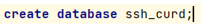

## 3.2 基本表的创建与管理

一共有11张表，分别为管理员账户表admin，楼栋信息表building，汽车信息表car，家庭信息表family，家庭账户表family_account_number，小区信息表housing_estate，停车场信息表parking，户主信息表people，宠物信息表pet，员工信息表staff，员工账户表staff_account_number

1.管理员账户表admin

其中有id与password两个属性

为id添加主键约束

为password添加默认约束，并设置默认值为‘123456’

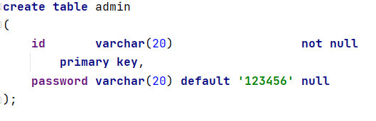

2.楼栋信息表building

其中有id，h_e_id，b_adresss，b_family，floor，unit，room七个属性

为id添加主键约束

为h_e_id添加非空约束与外键约束，外键为housing_estate表中的id属性

为b_adress添加非空约束

为b_family添加默认约束，其中默认值为0

为unit添加默认约束，其中默认值为0

为room添加默认约束，其中默认值为0

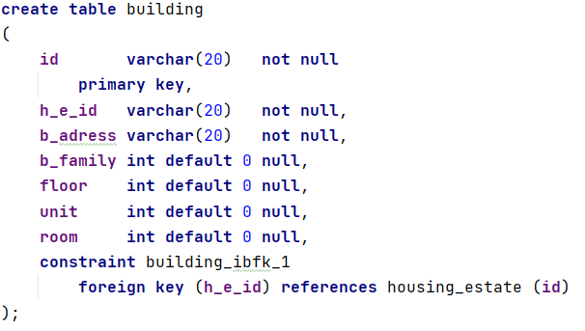

3.汽车信息表car

其中有id，f_id，color，brand，model五个属性

为id添加主键约束

为f_id添加非空约束与外键约束，其中外键为family中的id属性

为color添加非空约束

为brand添加非空约束

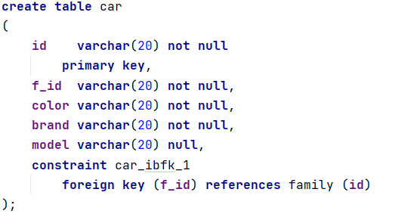

4.家庭信息表family

其中有id，h_e_id，family_number，parking，pet，people，car七个属性

为id添加主键约束

为f_id添加非空约束与外键约束，其中外键为family中的id属性

为family_number添加非空约束

为parking添加默认约束，其中默认值为0

为pet添加默认约束，其中默认值为0

为people添加默认约束，其中默认值为0

为car添加默认约束，其中默认值为0

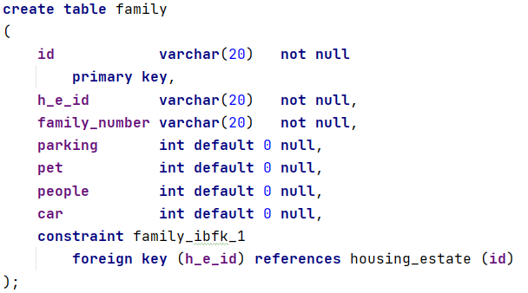

5. 家庭账户表family_account_number

其中有id，password，f_id三个属性

为id添加主键约束

为password添加非空约束

为f_id添加非空约束与外键约束，其中外键为family中的id属性

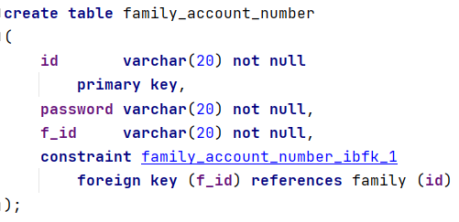

6. 小区信息表housing_estate

其中有id，h_e_adress，h_e_developer，h_e_area，h_e_pet，h_e_family，h_e_car，h_e_staff，h_e_staff，h_e_building，h_e_parking，h_e_name十一个属性

为id添加主键约束

为h_e_adress添加非空约束

为h_e_developer添加非空约束

为h_e_area添加默认约束，其中默认值为0

为h_e_pet添加默认约束，其中默认值为0

为h_e_family添加默认约束，其中默认值为0

为h_e_car添加默认约束，其中默认值为0

为h_e_staff添加默认约束，其中默认值为0

为h_e_building添加默认约束，其中默认值为0

为h_e_parking添加默认约束，其中默认值为0

为h_e_name添加非空约束

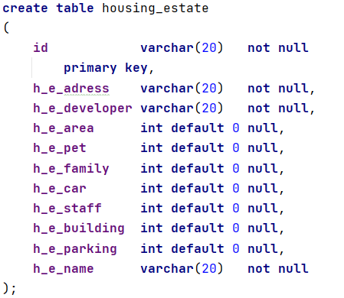

7. 停车场信息表parking

其中有adress，h_e_id，f_id三种属性

为adress添加主键约束

为h_e_id添加外键约束，其中外键为housing_estate中的id属性

为f_id添加外键约束，其中外键为family中的id属性

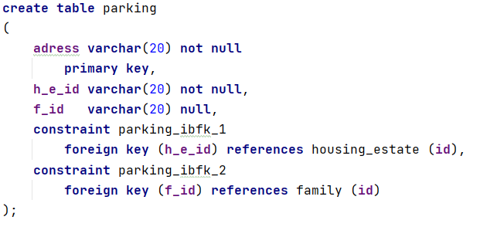

8. 户主信息表people

其中有id，f_id，pname，psex，page，pphone六种属性

为id添加主键约束

为f_id添加非空约束

为pname添加非空约束

为psex添加非空约束

为page添加默认约束，其中默认值为0

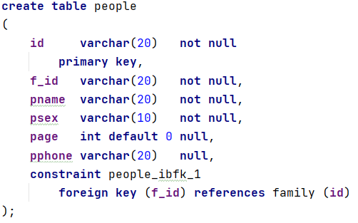

9.宠物信息表

其中有id，f_id，variety，sex，age五种属性

为id添加主键约束

为f_id添加外键约束，其中外键为family表中的id属性

为variety添加非空约束

为sex添加非空约束

为age添加默认约束，其中默认值为0

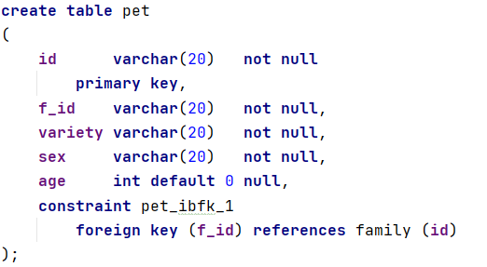

10.员工信息表

其中有id，h_e_id，s_name，s_sex，telephone，idcard，staff_position，wages八种属性

为id添加主键约束

为h_e_id添加外键约束，其中外键为housing_estate表中的id属性

为s_name添加非空约束

为s_sex添加非空约束

为s_age添加默认约束，其中默认值为0

为wages添加默认约束，其中默认值为0

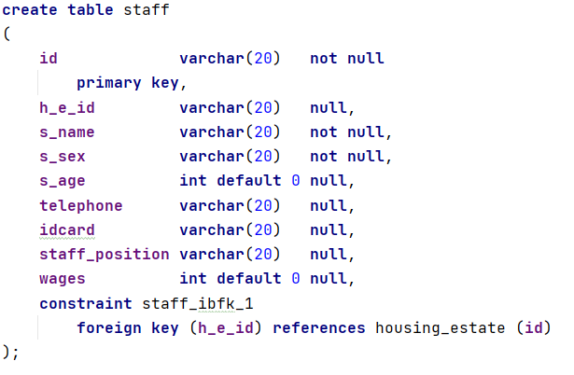

11. 员工账户表staff_account_number

其中有id，password，staff_id三种属性

为id添加主键约束

为password添加非空约束

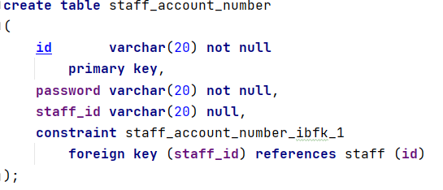

## 3.3 插入数据

本系统的数据均为excel生成的随机数据，用于模拟用户的操作

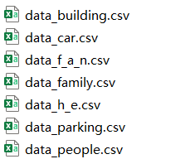

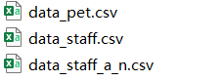

以family表中的数据作为例子

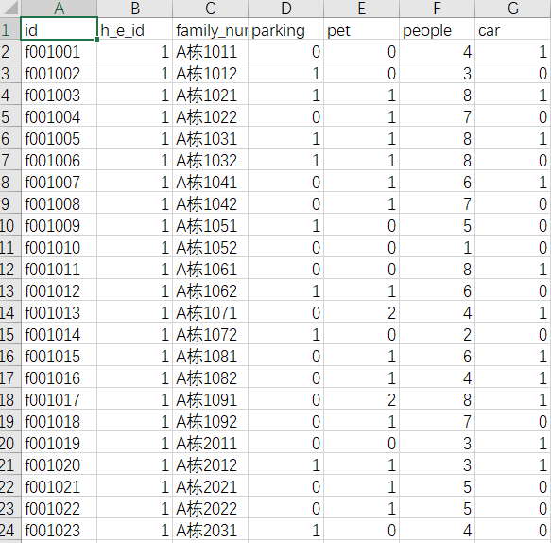

## 3.4访问数据库

尝试查询family表中的全部数据



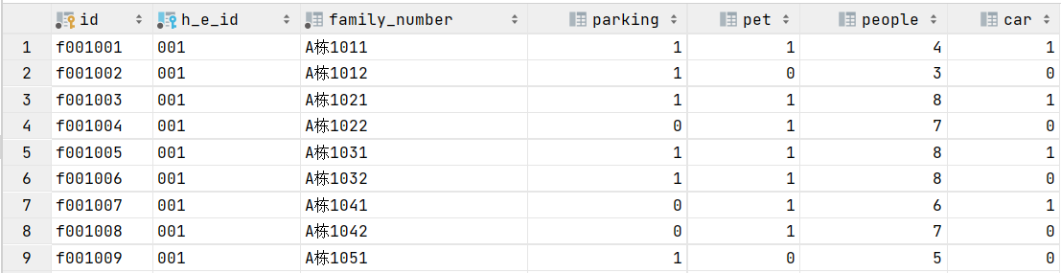

尝试插入一条新数据



尝试查询该数据





成功插入

尝试删除该数据

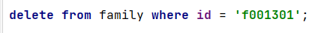

再次查询





该数据已经成功删除

# 4程序设计

## 4.1创建应用程序

创建各个界面对应的Python文件

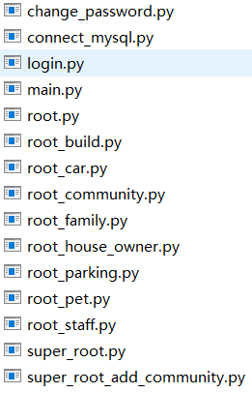

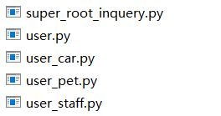

## 4.2连接数据库

使用PyMysql中的连接函数连接Myqsl数据库

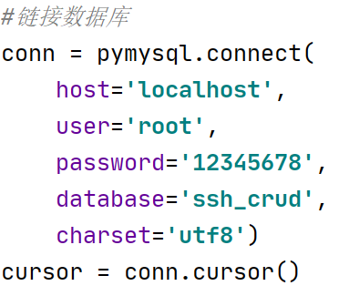

## 4.3设计应用程序

1）登入界面

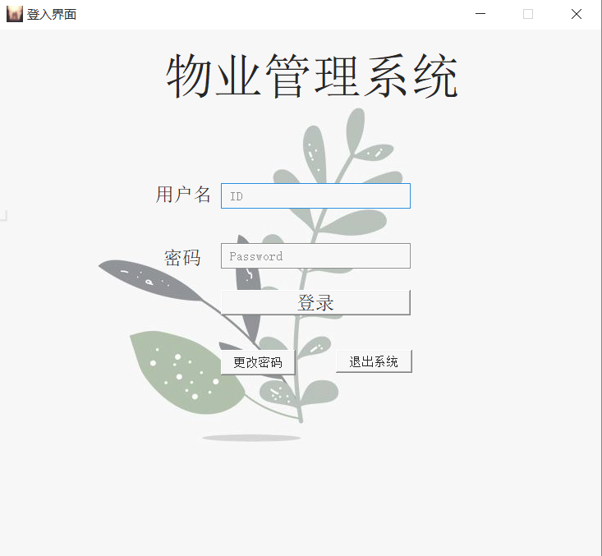

通过对输入的用户名和密码在数据库中查询后确定是否进入超级管理员界面、普通管理员界面、用户界面。

**相关代码：**

from PyQt5 import QtCore, QtGui, QtWidgets

from PyQt5.QtWidgets import *

import image.login_background

from change_password import *

import sys

class Ui_login(object):

def setupUi(self, MainWindow):

MainWindow.setObjectName("MainWindow")

MainWindow.resize(733, 644)

sizePolicy = QtWidgets.QSizePolicy(QtWidgets.QSizePolicy.Fixed, QtWidgets.QSizePolicy.Fixed)

sizePolicy.setHorizontalStretch(0)

sizePolicy.setVerticalStretch(0)

sizePolicy.setHeightForWidth(MainWindow.sizePolicy().hasHeightForWidth())

MainWindow.setSizePolicy(sizePolicy)

MainWindow.setMinimumSize(QtCore.QSize(733, 644))

MainWindow.setMaximumSize(QtCore.QSize(733, 644))

icon = QtGui.QIcon.fromTheme("D:\\python_projects\\DataBase\\image\\logo.png")

MainWindow.setWindowIcon(icon)

MainWindow.setWindowOpacity(0.85)

MainWindow.setStyleSheet(";\n"

"background-image: url(:/login_image/7.jpg);")

self.centralwidget = QtWidgets.QWidget(MainWindow)

sizePolicy = QtWidgets.QSizePolicy(QtWidgets.QSizePolicy.Fixed, QtWidgets.QSizePolicy.Fixed)

sizePolicy.setHorizontalStretch(0)

sizePolicy.setVerticalStretch(0)

sizePolicy.setHeightForWidth(self.centralwidget.sizePolicy().hasHeightForWidth())

self.centralwidget.setSizePolicy(sizePolicy)

self.centralwidget.setObjectName("centralwidget")

self.label_3 = QtWidgets.QLabel(self.centralwidget)

self.label_3.setGeometry(QtCore.QRect(200, 267, 51, 21))

self.label_3.setStyleSheet("font: 14pt \"Arial\";")

self.label_3.setObjectName("label_3")

self.pushButton_3 = QtWidgets.QPushButton(self.centralwidget)

self.pushButton_3.setGeometry(QtCore.QRect(410, 390, 93, 28))

self.pushButton_3.setObjectName("pushButton_3")

self.label_2 = QtWidgets.QLabel(self.centralwidget)

self.label_2.setGeometry(QtCore.QRect(190, 190, 71, 21))

self.label_2.setStyleSheet("font: 14pt \"Arial\";")

self.label_2.setObjectName("label_2")

self.lineEdit = QtWidgets.QLineEdit(self.centralwidget)

self.lineEdit.setGeometry(QtCore.QRect(270, 187, 231, 31))

sizePolicy = QtWidgets.QSizePolicy(QtWidgets.QSizePolicy.Fixed, QtWidgets.QSizePolicy.Fixed)

sizePolicy.setHorizontalStretch(0)

sizePolicy.setVerticalStretch(0)

sizePolicy.setHeightForWidth(self.lineEdit.sizePolicy().hasHeightForWidth())

self.lineEdit.setSizePolicy(sizePolicy)

self.lineEdit.setStyleSheet("background-color: qconicalgradient(cx:0.5, cy:0.5, angle:0, stop:0 rgba(35, 40, 3, 255), stop:0.16 rgba(136, 106, 22, 255), stop:0.225 rgba(166, 140, 41, 255), stop:0.285 rgba(204, 181, 74, 255), stop:0.345 rgba(235, 219, 102, 255), stop:0.415 rgba(245, 236, 112, 255), stop:0.52 rgba(209, 190, 76, 255), stop:0.57 rgba(187, 156, 51, 255), stop:0.635 rgba(168, 142, 42, 255), stop:0.695 rgba(202, 174, 68, 255), stop:0.75 rgba(218, 202, 86, 255), stop:0.815 rgba(208, 187, 73, 255), stop:0.88 rgba(187, 156, 51, 255), stop:0.935 rgba(137, 108, 26, 255), stop:1 rgba(35, 40, 3, 255));\n"

"background-color: rgb(255, 255, 255);")

self.lineEdit.setObjectName("lineEdit")

self.pushButton_2 = QtWidgets.QPushButton(self.centralwidget)

self.pushButton_2.setGeometry(QtCore.QRect(270, 390, 91, 31))

sizePolicy = QtWidgets.QSizePolicy(QtWidgets.QSizePolicy.Fixed, QtWidgets.QSizePolicy.Fixed)

sizePolicy.setHorizontalStretch(0)

sizePolicy.setVerticalStretch(0)

sizePolicy.setHeightForWidth(self.pushButton_2.sizePolicy().hasHeightForWidth())

self.pushButton_2.setSizePolicy(sizePolicy)

self.pushButton_2.setStyleSheet("")

self.pushButton_2.setObjectName("pushButton_2")

self.label = QtWidgets.QLabel(self.centralwidget)

self.label.setGeometry(QtCore.QRect(150, 27, 451, 61))

self.label.setStyleSheet("color: rgb(0, 0, 0);\n"

"font: 36pt \"Arial\";")

self.label.setObjectName("label")

self.pushButton = QtWidgets.QPushButton(self.centralwidget)

self.pushButton.setGeometry(QtCore.QRect(270, 317, 231, 31))

sizePolicy = QtWidgets.QSizePolicy(QtWidgets.QSizePolicy.Fixed, QtWidgets.QSizePolicy.Fixed)

sizePolicy.setHorizontalStretch(0)

sizePolicy.setVerticalStretch(0)

sizePolicy.setHeightForWidth(self.pushButton.sizePolicy().hasHeightForWidth())

self.pushButton.setSizePolicy(sizePolicy)

self.pushButton.setStyleSheet("font: 14pt \"Arial\";")

self.pushButton.setObjectName("pushButton")

self.lineEdit_2 = QtWidgets.QLineEdit(self.centralwidget)

self.lineEdit_2.setGeometry(QtCore.QRect(270, 260, 231, 31))

sizePolicy = QtWidgets.QSizePolicy(QtWidgets.QSizePolicy.Fixed, QtWidgets.QSizePolicy.Fixed)

sizePolicy.setHorizontalStretch(0)

sizePolicy.setVerticalStretch(0)

sizePolicy.setHeightForWidth(self.lineEdit_2.sizePolicy().hasHeightForWidth())

self.lineEdit_2.setSizePolicy(sizePolicy)

self.lineEdit_2.setStyleSheet("")

self.lineEdit_2.setText("")

self.lineEdit_2.setFrame(True)

self.lineEdit_2.setEchoMode(QtWidgets.QLineEdit.Password)

self.lineEdit_2.setObjectName("lineEdit_2")

MainWindow.setCentralWidget(self.centralwidget)

self.menubar = QtWidgets.QMenuBar(MainWindow)

self.menubar.setGeometry(QtCore.QRect(0, 0, 733, 26))

self.menubar.setObjectName("menubar")

MainWindow.setMenuBar(self.menubar)

self.statusbar = QtWidgets.QStatusBar(MainWindow)

self.statusbar.setObjectName("statusbar")

MainWindow.setStatusBar(self.statusbar)

self.retranslateUi(MainWindow)

QtCore.QMetaObject.connectSlotsByName(MainWindow)

def retranslateUi(self, MainWindow):

_translate = QtCore.QCoreApplication.translate

MainWindow.setWindowTitle(_translate("MainWindow", "登入界面"))

self.label_3.setText(_translate("MainWindow", "密码"))

self.pushButton_3.setText(_translate("MainWindow", "退出系统"))

self.label_2.setText(_translate("MainWindow", "用户名"))

self.lineEdit.setPlaceholderText(_translate("MainWindow", " ID"))

self.pushButton_2.setText(_translate("MainWindow", "更改密码"))

self.label.setText(_translate("MainWindow", " 物业管理系统"))

self.pushButton.setText(_translate("MainWindow", "登录"))

self.lineEdit_2.setPlaceholderText(_translate("MainWindow", " Password"))

2）修改密码界面

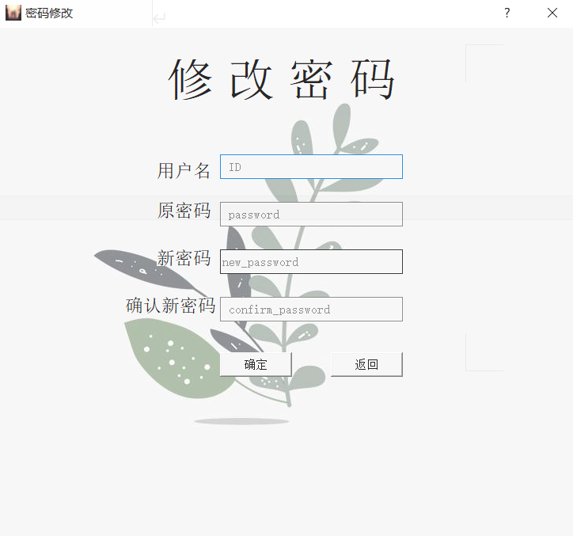

输入用户名、原密码、新密码确定密码的修改。

**相关代码：**

from PyQt5 import QtCore, QtGui, QtWidgets

import image.change_password

from PyQt5.QtWidgets import *

from change_password import *

import sys

class Ui_change_password(object):

def setupUi(self, Form):

Form.setObjectName("Form")

Form.resize(730, 644)

Form.setMinimumSize(QtCore.QSize(730, 644))

Form.setMaximumSize(QtCore.QSize(730, 644))

icon = QtGui.QIcon.fromTheme("D:\\python_projects\\DataBase\\image\\logo.png")

Form.setWindowIcon(icon)

Form.setWindowOpacity(0.85)

Form.setStyleSheet("background-image: url(:/background/7.jpg);")

self.label_2 = QtWidgets.QLabel(Form)

self.label_2.setGeometry(QtCore.QRect(200, 170, 71, 21))

self.label_2.setStyleSheet("font: 14pt \"Arial\";")

self.label_2.setObjectName("label_2")

self.lineEdit = QtWidgets.QLineEdit(Form)

self.lineEdit.setGeometry(QtCore.QRect(280, 160, 231, 31))

sizePolicy = QtWidgets.QSizePolicy(QtWidgets.QSizePolicy.Fixed, QtWidgets.QSizePolicy.Fixed)

sizePolicy.setHorizontalStretch(0)

sizePolicy.setVerticalStretch(0)

sizePolicy.setHeightForWidth(self.lineEdit.sizePolicy().hasHeightForWidth())

self.lineEdit.setSizePolicy(sizePolicy)

self.lineEdit.setStyleSheet("background-color: qconicalgradient(cx:0.5, cy:0.5, angle:0, stop:0 rgba(35, 40, 3, 255), stop:0.16 rgba(136, 106, 22, 255), stop:0.225 rgba(166, 140, 41, 255), stop:0.285 rgba(204, 181, 74, 255), stop:0.345 rgba(235, 219, 102, 255), stop:0.415 rgba(245, 236, 112, 255), stop:0.52 rgba(209, 190, 76, 255), stop:0.57 rgba(187, 156, 51, 255), stop:0.635 rgba(168, 142, 42, 255), stop:0.695 rgba(202, 174, 68, 255), stop:0.75 rgba(218, 202, 86, 255), stop:0.815 rgba(208, 187, 73, 255), stop:0.88 rgba(187, 156, 51, 255), stop:0.935 rgba(137, 108, 26, 255), stop:1 rgba(35, 40, 3, 255));\n"

"background-color: rgb(255, 255, 255);")

self.lineEdit.setObjectName("lineEdit")

self.lineEdit_2 = QtWidgets.QLineEdit(Form)

self.lineEdit_2.setGeometry(QtCore.QRect(280, 220, 231, 31))

sizePolicy = QtWidgets.QSizePolicy(QtWidgets.QSizePolicy.Fixed, QtWidgets.QSizePolicy.Fixed)

sizePolicy.setHorizontalStretch(0)

sizePolicy.setVerticalStretch(0)

sizePolicy.setHeightForWidth(self.lineEdit_2.sizePolicy().hasHeightForWidth())

self.lineEdit_2.setSizePolicy(sizePolicy)

self.lineEdit_2.setStyleSheet("background-color: qconicalgradient(cx:0.5, cy:0.5, angle:0, stop:0 rgba(35, 40, 3, 255), stop:0.16 rgba(136, 106, 22, 255), stop:0.225 rgba(166, 140, 41, 255), stop:0.285 rgba(204, 181, 74, 255), stop:0.345 rgba(235, 219, 102, 255), stop:0.415 rgba(245, 236, 112, 255), stop:0.52 rgba(209, 190, 76, 255), stop:0.57 rgba(187, 156, 51, 255), stop:0.635 rgba(168, 142, 42, 255), stop:0.695 rgba(202, 174, 68, 255), stop:0.75 rgba(218, 202, 86, 255), stop:0.815 rgba(208, 187, 73, 255), stop:0.88 rgba(187, 156, 51, 255), stop:0.935 rgba(137, 108, 26, 255), stop:1 rgba(35, 40, 3, 255));\n"

"background-color: rgb(255, 255, 255);")

self.lineEdit_2.setEchoMode(QtWidgets.QLineEdit.Password)

self.lineEdit_2.setObjectName("lineEdit_2")

self.label_3 = QtWidgets.QLabel(Form)

self.label_3.setGeometry(QtCore.QRect(160, 340, 121, 21))

self.label_3.setStyleSheet("font: 14pt \"Arial\";")

self.label_3.setObjectName("label_3")

self.lineEdit_3 = QtWidgets.QLineEdit(Form)

self.lineEdit_3.setGeometry(QtCore.QRect(280, 280, 231, 31))

sizePolicy = QtWidgets.QSizePolicy(QtWidgets.QSizePolicy.Fixed, QtWidgets.QSizePolicy.Fixed)

sizePolicy.setHorizontalStretch(0)

sizePolicy.setVerticalStretch(0)

sizePolicy.setHeightForWidth(self.lineEdit_3.sizePolicy().hasHeightForWidth())

self.lineEdit_3.setSizePolicy(sizePolicy)

self.lineEdit_3.setStyleSheet("background-color: qconicalgradient(cx:0.5, cy:0.5, angle:0, stop:0 rgba(35, 40, 3, 255), stop:0.16 rgba(136, 106, 22, 255), stop:0.225 rgba(166, 140, 41, 255), stop:0.285 rgba(204, 181, 74, 255), stop:0.345 rgba(235, 219, 102, 255), stop:0.415 rgba(245, 236, 112, 255), stop:0.52 rgba(209, 190, 76, 255), stop:0.57 rgba(187, 156, 51, 255), stop:0.635 rgba(168, 142, 42, 255), stop:0.695 rgba(202, 174, 68, 255), stop:0.75 rgba(218, 202, 86, 255), stop:0.815 rgba(208, 187, 73, 255), stop:0.88 rgba(187, 156, 51, 255), stop:0.935 rgba(137, 108, 26, 255), stop:1 rgba(35, 40, 3, 255));\n"

"background-color: rgb(255, 255, 255);")

self.lineEdit_3.setEchoMode(QtWidgets.QLineEdit.Password)

self.lineEdit_3.setObjectName("lineEdit_3")

self.label_4 = QtWidgets.QLabel(Form)

self.label_4.setGeometry(QtCore.QRect(200, 280, 71, 21))

self.label_4.setStyleSheet("font: 14pt \"Arial\";")

self.label_4.setObjectName("label_4")

self.lineEdit_4 = QtWidgets.QLineEdit(Form)

self.lineEdit_4.setGeometry(QtCore.QRect(280, 340, 231, 31))

sizePolicy = QtWidgets.QSizePolicy(QtWidgets.QSizePolicy.Fixed, QtWidgets.QSizePolicy.Fixed)

sizePolicy.setHorizontalStretch(0)

sizePolicy.setVerticalStretch(0)

sizePolicy.setHeightForWidth(self.lineEdit_4.sizePolicy().hasHeightForWidth())

self.lineEdit_4.setSizePolicy(sizePolicy)

self.lineEdit_4.setStyleSheet("background-color: qconicalgradient(cx:0.5, cy:0.5, angle:0, stop:0 rgba(35, 40, 3, 255), stop:0.16 rgba(136, 106, 22, 255), stop:0.225 rgba(166, 140, 41, 255), stop:0.285 rgba(204, 181, 74, 255), stop:0.345 rgba(235, 219, 102, 255), stop:0.415 rgba(245, 236, 112, 255), stop:0.52 rgba(209, 190, 76, 255), stop:0.57 rgba(187, 156, 51, 255), stop:0.635 rgba(168, 142, 42, 255), stop:0.695 rgba(202, 174, 68, 255), stop:0.75 rgba(218, 202, 86, 255), stop:0.815 rgba(208, 187, 73, 255), stop:0.88 rgba(187, 156, 51, 255), stop:0.935 rgba(137, 108, 26, 255), stop:1 rgba(35, 40, 3, 255));\n"

"background-color: rgb(255, 255, 255);")

self.lineEdit_4.setEchoMode(QtWidgets.QLineEdit.Password)

self.lineEdit_4.setObjectName("lineEdit_4")

self.label_5 = QtWidgets.QLabel(Form)

self.label_5.setGeometry(QtCore.QRect(200, 220, 71, 21))

self.label_5.setStyleSheet("font: 14pt \"Arial\";")

self.label_5.setObjectName("label_5")

self.pushButton = QtWidgets.QPushButton(Form)

self.pushButton.setGeometry(QtCore.QRect(280, 410, 91, 31))

self.pushButton.setObjectName("pushButton")

self.pushButton_2 = QtWidgets.QPushButton(Form)

self.pushButton_2.setGeometry(QtCore.QRect(420, 410, 91, 31))

self.pushButton_2.setObjectName("pushButton_2")

self.label = QtWidgets.QLabel(Form)

self.label.setGeometry(QtCore.QRect(110, 40, 471, 51))

self.label.setStyleSheet("color: rgb(0, 0, 0);\n"

"font: 36pt \"Arial\";")

self.label.setObjectName("label")

self.retranslateUi(Form)

QtCore.QMetaObject.connectSlotsByName(Form)

def retranslateUi(self, Form):

_translate = QtCore.QCoreApplication.translate

Form.setWindowTitle(_translate("Form", "密码修改"))

self.label_2.setText(_translate("Form", "用户名"))

self.lineEdit.setPlaceholderText(_translate("Form", " ID"))

self.lineEdit_2.setPlaceholderText(_translate("Form", " password"))

self.label_3.setText(_translate("Form", "确认新密码"))

self.lineEdit_3.setPlaceholderText(_translate("Form", "new_password"))

self.label_4.setText(_translate("Form", "新密码"))

self.lineEdit_4.setPlaceholderText(_translate("Form", " confirm_password"))

self.label_5.setText(_translate("Form", "原密码"))

self.pushButton.setText(_translate("Form", "确定"))

self.pushButton_2.setText(_translate("Form", "返回"))

self.label.setText(_translate("Form", " 修 改 密 码"))

3）超级管理员界面

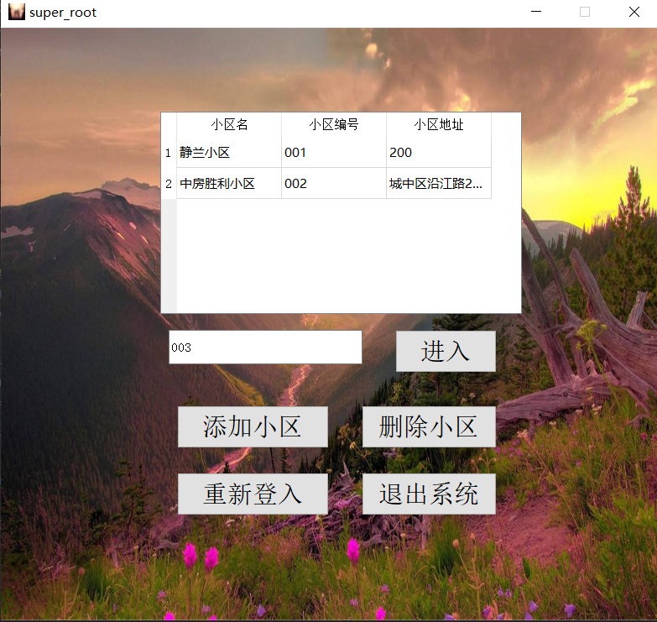

添加小区编号，点击进入不同小区界面。

**相关代码：**

from PyQt5 import QtCore, QtGui, QtWidgets

import image.super_root

class Ui_super_root(object):

def setupUi(self, MainWindow):

MainWindow.setObjectName("MainWindow")

MainWindow.resize(785, 706)

MainWindow.setMinimumSize(QtCore.QSize(785, 706))

MainWindow.setMaximumSize(QtCore.QSize(785, 706))

MainWindow.setWindowOpacity(1.0)

MainWindow.setStyleSheet("#centralwidget{border-image: url(:/background/background1.jpg);}")

self.centralwidget = QtWidgets.QWidget(MainWindow)

self.centralwidget.setObjectName("centralwidget")

self.lineEdit = QtWidgets.QLineEdit(self.centralwidget)

self.lineEdit.setGeometry(QtCore.QRect(200, 360, 231, 41))

self.lineEdit.setObjectName("lineEdit")

self.pushButton = QtWidgets.QPushButton(self.centralwidget)

self.pushButton.setGeometry(QtCore.QRect(470, 360, 121, 51))

self.pushButton.setStyleSheet("font: 18pt \"Arial\";")

self.pushButton.setObjectName("pushButton")

self.pushButton_2 = QtWidgets.QPushButton(self.centralwidget)

self.pushButton_2.setGeometry(QtCore.QRect(210, 450, 181, 51))

self.pushButton_2.setStyleSheet("font: 18pt \"Arial\";")

self.pushButton_2.setObjectName("pushButton_2")

self.pushButton_3 = QtWidgets.QPushButton(self.centralwidget)

self.pushButton_3.setGeometry(QtCore.QRect(430, 450, 161, 51))

self.pushButton_3.setStyleSheet("font: 18pt \"Arial\";")

self.pushButton_3.setObjectName("pushButton_3")

self.pushButton_4 = QtWidgets.QPushButton(self.centralwidget)

self.pushButton_4.setGeometry(QtCore.QRect(210, 530, 181, 51))

self.pushButton_4.setStyleSheet("font: 18pt \"Arial\";")

self.pushButton_4.setObjectName("pushButton_4")

self.pushButton_5 = QtWidgets.QPushButton(self.centralwidget)

self.pushButton_5.setGeometry(QtCore.QRect(430, 530, 161, 51))

self.pushButton_5.setStyleSheet("font: 18pt \"Arial\";")

self.pushButton_5.setObjectName("pushButton_5")

self.tableWidget = QtWidgets.QTableWidget(self.centralwidget)

self.tableWidget.setGeometry(QtCore.QRect(190, 100, 431, 241))

self.tableWidget.setObjectName("tableWidget")

self.tableWidget.setColumnCount(3)

self.tableWidget.setRowCount(10)

item = QtWidgets.QTableWidgetItem()

self.tableWidget.setVerticalHeaderItem(0, item)

item = QtWidgets.QTableWidgetItem()

self.tableWidget.setVerticalHeaderItem(1, item)

item = QtWidgets.QTableWidgetItem()

self.tableWidget.setVerticalHeaderItem(2, item)

item = QtWidgets.QTableWidgetItem()

self.tableWidget.setVerticalHeaderItem(3, item)

item = QtWidgets.QTableWidgetItem()

self.tableWidget.setVerticalHeaderItem(4, item)

item = QtWidgets.QTableWidgetItem()

self.tableWidget.setVerticalHeaderItem(5, item)

item = QtWidgets.QTableWidgetItem()

self.tableWidget.setVerticalHeaderItem(6, item)

item = QtWidgets.QTableWidgetItem()

self.tableWidget.setVerticalHeaderItem(7, item)

item = QtWidgets.QTableWidgetItem()

self.tableWidget.setVerticalHeaderItem(8, item)

item = QtWidgets.QTableWidgetItem()

self.tableWidget.setVerticalHeaderItem(9, item)

item = QtWidgets.QTableWidgetItem()

self.tableWidget.setHorizontalHeaderItem(0, item)

item = QtWidgets.QTableWidgetItem()

self.tableWidget.setHorizontalHeaderItem(1, item)

item = QtWidgets.QTableWidgetItem()

self.tableWidget.setHorizontalHeaderItem(2, item)

MainWindow.setCentralWidget(self.centralwidget)

self.retranslateUi(MainWindow)

QtCore.QMetaObject.connectSlotsByName(MainWindow)

def retranslateUi(self, MainWindow):

_translate = QtCore.QCoreApplication.translate

MainWindow.setWindowTitle(_translate("MainWindow", "super_root"))

self.lineEdit.setPlaceholderText(_translate("MainWindow", "请输入小区编号"))

self.pushButton.setText(_translate("MainWindow", "进入"))

self.pushButton_2.setText(_translate("MainWindow", "添加小区"))

self.pushButton_3.setText(_translate("MainWindow", "删除小区"))

self.pushButton_4.setText(_translate("MainWindow", "重新登入"))

self.pushButton_5.setText(_translate("MainWindow", "退出系统"))

item = self.tableWidget.verticalHeaderItem(0)

item.setText(_translate("MainWindow", "1"))

item = self.tableWidget.verticalHeaderItem(1)

item.setText(_translate("MainWindow", "2"))

item = self.tableWidget.verticalHeaderItem(2)

item.setText(_translate("MainWindow", "3"))

item = self.tableWidget.verticalHeaderItem(3)

item.setText(_translate("MainWindow", "4"))

item = self.tableWidget.verticalHeaderItem(4)

item.setText(_translate("MainWindow", "5"))

item = self.tableWidget.verticalHeaderItem(5)

item.setText(_translate("MainWindow", "6"))

item = self.tableWidget.verticalHeaderItem(6)

item.setText(_translate("MainWindow", "7"))

item = self.tableWidget.verticalHeaderItem(7)

item.setText(_translate("MainWindow", "8"))

item = self.tableWidget.verticalHeaderItem(8)

item.setText(_translate("MainWindow", "9"))

item = self.tableWidget.verticalHeaderItem(9)

item.setText(_translate("MainWindow", "10"))

item = self.tableWidget.horizontalHeaderItem(0)

item.setText(_translate("MainWindow", "小区名"))

item = self.tableWidget.horizontalHeaderItem(1)

item.setText(_translate("MainWindow", "小区编号"))

item = self.tableWidget.horizontalHeaderItem(2)

item.setText(_translate("MainWindow", "小区地址"))

4）普通管理员界面

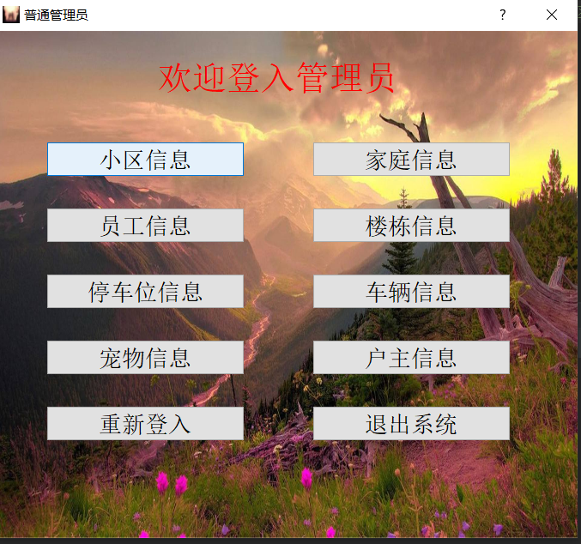

点击不同的按钮进入不同的信息界面进行相应信息的增删查改。

**相关代码：**

from PyQt5 import QtCore, QtGui, QtWidgets

import image.root_community

class Ui_root_community(object):

def setupUi(self, MainWindow):

MainWindow.setObjectName("MainWindow")

MainWindow.resize(1163, 882)

MainWindow.setMinimumSize(QtCore.QSize(1163, 882))

MainWindow.setMaximumSize(QtCore.QSize(1163, 882))

MainWindow.setStyleSheet("#centralwidget{border-image: url(:/background/background1.jpg);}")

self.centralwidget = QtWidgets.QWidget(MainWindow)

self.centralwidget.setObjectName("centralwidget")

self.tableWidget = QtWidgets.QTableWidget(self.centralwidget)

self.tableWidget.setGeometry(QtCore.QRect(130, 140, 881, 131))

self.tableWidget.setAlternatingRowColors(True)

self.tableWidget.setObjectName("tableWidget")

self.tableWidget.setColumnCount(11)

self.tableWidget.setRowCount(0)

item = QtWidgets.QTableWidgetItem()

self.tableWidget.setHorizontalHeaderItem(0, item)

item = QtWidgets.QTableWidgetItem()

self.tableWidget.setHorizontalHeaderItem(1, item)

item = QtWidgets.QTableWidgetItem()

self.tableWidget.setHorizontalHeaderItem(2, item)

item = QtWidgets.QTableWidgetItem()

self.tableWidget.setHorizontalHeaderItem(3, item)

item = QtWidgets.QTableWidgetItem()

self.tableWidget.setHorizontalHeaderItem(4, item)

item = QtWidgets.QTableWidgetItem()

self.tableWidget.setHorizontalHeaderItem(5, item)

item = QtWidgets.QTableWidgetItem()

self.tableWidget.setHorizontalHeaderItem(6, item)

item = QtWidgets.QTableWidgetItem()

self.tableWidget.setHorizontalHeaderItem(7, item)

item = QtWidgets.QTableWidgetItem()

self.tableWidget.setHorizontalHeaderItem(8, item)

item = QtWidgets.QTableWidgetItem()

self.tableWidget.setHorizontalHeaderItem(9, item)

item = QtWidgets.QTableWidgetItem()

self.tableWidget.setHorizontalHeaderItem(10, item)

self.lineEdit = QtWidgets.QLineEdit(self.centralwidget)

self.lineEdit.setGeometry(QtCore.QRect(130, 280, 231, 51))

self.lineEdit.setObjectName("lineEdit")

self.lineEdit_2 = QtWidgets.QLineEdit(self.centralwidget)

self.lineEdit_2.setGeometry(QtCore.QRect(410, 280, 271, 51))

self.lineEdit_2.setObjectName("lineEdit_2")

self.lineEdit_3 = QtWidgets.QLineEdit(self.centralwidget)

self.lineEdit_3.setGeometry(QtCore.QRect(750, 280, 271, 51))

self.lineEdit_3.setObjectName("lineEdit_3")

self.lineEdit_4 = QtWidgets.QLineEdit(self.centralwidget)

self.lineEdit_4.setGeometry(QtCore.QRect(130, 370, 231, 51))

self.lineEdit_4.setObjectName("lineEdit_4")

self.lineEdit_5 = QtWidgets.QLineEdit(self.centralwidget)

self.lineEdit_5.setGeometry(QtCore.QRect(410, 370, 271, 51))

self.lineEdit_5.setObjectName("lineEdit_5")

self.pushButton_3 = QtWidgets.QPushButton(self.centralwidget)

self.pushButton_3.setGeometry(QtCore.QRect(620, 610, 401, 81))

self.pushButton_3.setStyleSheet("font: 18pt \"Arial\";")

self.pushButton_3.setObjectName("pushButton_3")

self.pushButton_4 = QtWidgets.QPushButton(self.centralwidget)

self.pushButton_4.setGeometry(QtCore.QRect(120, 720, 401, 81))

self.pushButton_4.setStyleSheet("font: 18pt \"Arial\";")

self.pushButton_4.setObjectName("pushButton_4")

self.pushButton_6 = QtWidgets.QPushButton(self.centralwidget)

self.pushButton_6.setGeometry(QtCore.QRect(620, 720, 401, 81))

self.pushButton_6.setStyleSheet("font: 18pt \"Arial\";")

self.pushButton_6.setObjectName("pushButton_6")

self.label = QtWidgets.QLabel(self.centralwidget)

self.label.setGeometry(QtCore.QRect(460, 70, 281, 51))

self.label.setStyleSheet("font: 28pt \"Arial\";")

self.label.setObjectName("label")

self.pushButton_2 = QtWidgets.QPushButton(self.centralwidget)

self.pushButton_2.setGeometry(QtCore.QRect(120, 610, 401, 81))

self.pushButton_2.setStyleSheet("font: 18pt \"Arial\";")

self.pushButton_2.setObjectName("pushButton_2")

self.pushButton_1 = QtWidgets.QPushButton(self.centralwidget)

self.pushButton_1.setGeometry(QtCore.QRect(130, 80, 131, 51))

self.pushButton_1.setStyleSheet("font: 18pt \"Arial\";")

self.pushButton_1.setObjectName("pushButton_1")

self.lineEdit_6 = QtWidgets.QLineEdit(self.centralwidget)

self.lineEdit_6.setGeometry(QtCore.QRect(750, 360, 271, 51))

self.lineEdit_6.setObjectName("lineEdit_6")

self.lineEdit_7 = QtWidgets.QLineEdit(self.centralwidget)

self.lineEdit_7.setGeometry(QtCore.QRect(130, 450, 231, 51))

self.lineEdit_7.setObjectName("lineEdit_7")

self.lineEdit_8 = QtWidgets.QLineEdit(self.centralwidget)

self.lineEdit_8.setGeometry(QtCore.QRect(410, 450, 271, 51))

self.lineEdit_8.setObjectName("lineEdit_8")

self.lineEdit_9 = QtWidgets.QLineEdit(self.centralwidget)

self.lineEdit_9.setGeometry(QtCore.QRect(750, 450, 271, 51))

self.lineEdit_9.setObjectName("lineEdit_9")

self.lineEdit_10 = QtWidgets.QLineEdit(self.centralwidget)

self.lineEdit_10.setGeometry(QtCore.QRect(270, 530, 231, 51))

self.lineEdit_10.setObjectName("lineEdit_10")

self.lineEdit_11 = QtWidgets.QLineEdit(self.centralwidget)

self.lineEdit_11.setGeometry(QtCore.QRect(600, 530, 251, 51))

self.lineEdit_11.setObjectName("lineEdit_11")

MainWindow.setCentralWidget(self.centralwidget)

self.retranslateUi(MainWindow)

QtCore.QMetaObject.connectSlotsByName(MainWindow)

def retranslateUi(self, MainWindow):

_translate = QtCore.QCoreApplication.translate

MainWindow.setWindowTitle(_translate("MainWindow", "root_小区信息"))

item = self.tableWidget.horizontalHeaderItem(0)

item.setText(_translate("MainWindow", "小区编号"))

item = self.tableWidget.horizontalHeaderItem(1)

item.setText(_translate("MainWindow", "小区名"))

item = self.tableWidget.horizontalHeaderItem(2)

item.setText(_translate("MainWindow", "开发商"))

item = self.tableWidget.horizontalHeaderItem(3)

item.setText(_translate("MainWindow", "小区面积"))

item = self.tableWidget.horizontalHeaderItem(4)

item.setText(_translate("MainWindow", "小区员工数量"))

item = self.tableWidget.horizontalHeaderItem(5)

item.setText(_translate("MainWindow", "小区地址"))

item = self.tableWidget.horizontalHeaderItem(6)

item.setText(_translate("MainWindow", "小区住户数量"))

item = self.tableWidget.horizontalHeaderItem(7)

item.setText(_translate("MainWindow", "小区停车位数量"))

item = self.tableWidget.horizontalHeaderItem(8)

item.setText(_translate("MainWindow", "小区宠物数量"))

item = self.tableWidget.horizontalHeaderItem(9)

item.setText(_translate("MainWindow", "小区楼栋数量"))

item = self.tableWidget.horizontalHeaderItem(10)

item.setText(_translate("MainWindow", "小区车辆数量"))

self.lineEdit.setPlaceholderText(_translate("MainWindow", "请输入小区编号"))

self.lineEdit_2.setPlaceholderText(_translate("MainWindow", "请输入小区名"))

self.lineEdit_3.setPlaceholderText(_translate("MainWindow", "请输入开发商"))

self.lineEdit_4.setPlaceholderText(_translate("MainWindow", "请输入小区面积"))

self.lineEdit_5.setPlaceholderText(_translate("MainWindow", "请输入小区员工数量"))

self.pushButton_3.setText(_translate("MainWindow", "更改"))

self.pushButton_4.setText(_translate("MainWindow", "返回"))

self.pushButton_6.setText(_translate("MainWindow", "退出系统"))

self.label.setText(_translate("MainWindow", " 小区信息"))

self.pushButton_2.setText(_translate("MainWindow", "全部查询"))

self.pushButton_1.setText(_translate("MainWindow", "清屏"))

self.lineEdit_6.setPlaceholderText(_translate("MainWindow", "请输入小区地址"))

self.lineEdit_7.setPlaceholderText(_translate("MainWindow", "请输入小区住户数量"))

self.lineEdit_8.setPlaceholderText(_translate("MainWindow", "请输入小区停车位数量"))

self.lineEdit_9.setPlaceholderText(_translate("MainWindow", "请输入小区宠物数量"))

self.lineEdit_10.setPlaceholderText(_translate("MainWindow", "请输入小区楼栋"))

self.lineEdit_11.setPlaceholderText(_translate("MainWindow", "请输入小区车辆"))

5）用户界面

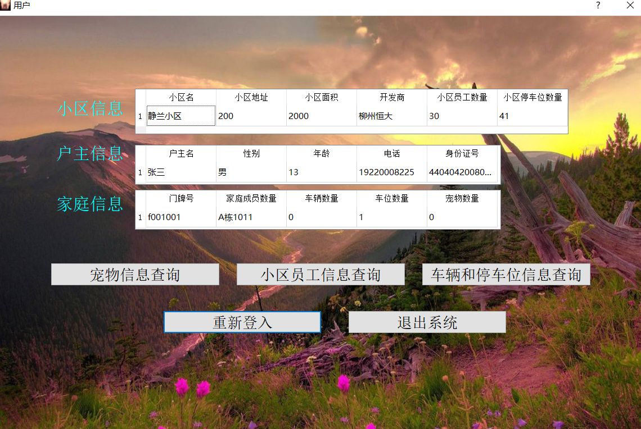

用户界面会自动判断当前登入用户属于哪个小区，并在打开时自动显示小区信息，户主信息，家庭信息。用户手动点击相关信息按钮查询自身相关信息。

**相关代码：**

from PyQt5 import QtCore, QtGui, QtWidgets

import image.root

class Ui_root(object):

def setupUi(self, Form):

Form.setObjectName("Form")

Form.resize(679, 591)

Form.setMinimumSize(QtCore.QSize(679, 591))

Form.setMaximumSize(QtCore.QSize(679, 591))

Form.setStyleSheet("#Form{border-image: url(:/background/background1.jpg);}")

self.label = QtWidgets.QLabel(Form)

self.label.setGeometry(QtCore.QRect(190, 30, 291, 51))

self.label.setStyleSheet("font: 24pt \"Arial\";\n"

"color: rgb(255, 0, 0);")

self.label.setObjectName("label")

self.widget = QtWidgets.QWidget(Form)

self.widget.setGeometry(QtCore.QRect(60, 100, 231, 411))

self.widget.setObjectName("widget")

self.verticalLayout = QtWidgets.QVBoxLayout(self.widget)

self.verticalLayout.setContentsMargins(0, 0, 0, 0)

self.verticalLayout.setObjectName("verticalLayout")

self.pushButton = QtWidgets.QPushButton(self.widget)

self.pushButton.setStyleSheet("font: 16pt \"Arial\";")

self.pushButton.setObjectName("pushButton")

self.verticalLayout.addWidget(self.pushButton)

self.pushButton_3 = QtWidgets.QPushButton(self.widget)

self.pushButton_3.setStyleSheet("font: 16pt \"Arial\";")

self.pushButton_3.setObjectName("pushButton_3")

self.verticalLayout.addWidget(self.pushButton_3)

self.pushButton_5 = QtWidgets.QPushButton(self.widget)

self.pushButton_5.setStyleSheet("font: 16pt \"Arial\";")

self.pushButton_5.setObjectName("pushButton_5")

self.verticalLayout.addWidget(self.pushButton_5)

self.pushButton_7 = QtWidgets.QPushButton(self.widget)

self.pushButton_7.setStyleSheet("font: 16pt \"Arial\";")

self.pushButton_7.setObjectName("pushButton_7")

self.verticalLayout.addWidget(self.pushButton_7)

self.pushButton_9 = QtWidgets.QPushButton(self.widget)

self.pushButton_9.setStyleSheet("font: 16pt \"Arial\";")

self.pushButton_9.setObjectName("pushButton_9")

self.verticalLayout.addWidget(self.pushButton_9)

self.widget1 = QtWidgets.QWidget(Form)

self.widget1.setGeometry(QtCore.QRect(370, 100, 231, 411))

self.widget1.setObjectName("widget1")

self.verticalLayout_2 = QtWidgets.QVBoxLayout(self.widget1)

self.verticalLayout_2.setContentsMargins(0, 0, 0, 0)

self.verticalLayout_2.setObjectName("verticalLayout_2")

self.pushButton_2 = QtWidgets.QPushButton(self.widget1)

self.pushButton_2.setStyleSheet("font: 16pt \"Arial\";")

self.pushButton_2.setObjectName("pushButton_2")

self.verticalLayout_2.addWidget(self.pushButton_2)

self.pushButton_4 = QtWidgets.QPushButton(self.widget1)

self.pushButton_4.setStyleSheet("font: 16pt \"Arial\";")

self.pushButton_4.setObjectName("pushButton_4")

self.verticalLayout_2.addWidget(self.pushButton_4)

self.pushButton_6 = QtWidgets.QPushButton(self.widget1)

self.pushButton_6.setStyleSheet("font: 16pt \"Arial\";")

self.pushButton_6.setObjectName("pushButton_6")

self.verticalLayout_2.addWidget(self.pushButton_6)

self.pushButton_8 = QtWidgets.QPushButton(self.widget1)

self.pushButton_8.setStyleSheet("font: 16pt \"Arial\";")

self.pushButton_8.setObjectName("pushButton_8")

self.verticalLayout_2.addWidget(self.pushButton_8)

self.pushButton_10 = QtWidgets.QPushButton(self.widget1)

self.pushButton_10.setStyleSheet("font: 16pt \"Arial\";")

self.pushButton_10.setObjectName("pushButton_10")

self.verticalLayout_2.addWidget(self.pushButton_10)

self.retranslateUi(Form)

QtCore.QMetaObject.connectSlotsByName(Form)

def retranslateUi(self, Form):

_translate = QtCore.QCoreApplication.translate

Form.setWindowTitle(_translate("Form", "普通管理员"))

self.label.setText(_translate("Form", "欢迎登入管理员"))

self.pushButton.setText(_translate("Form", "小区信息"))

self.pushButton_3.setText(_translate("Form", "员工信息"))

self.pushButton_5.setText(_translate("Form", "停车位信息"))

self.pushButton_7.setText(_translate("Form", "宠物信息"))

self.pushButton_9.setText(_translate("Form", "重新登入"))

self.pushButton_2.setText(_translate("Form", "家庭信息"))

self.pushButton_4.setText(_translate("Form", "楼栋信息"))

self.pushButton_6.setText(_translate("Form", "车辆信息"))

self.pushButton_8.setText(_translate("Form", "户主信息"))

self.pushButton_10.setText(_translate("Form", "退出系统"))

# 5测试用例

## 5.1 超级管理员测试

1.对小区的操作

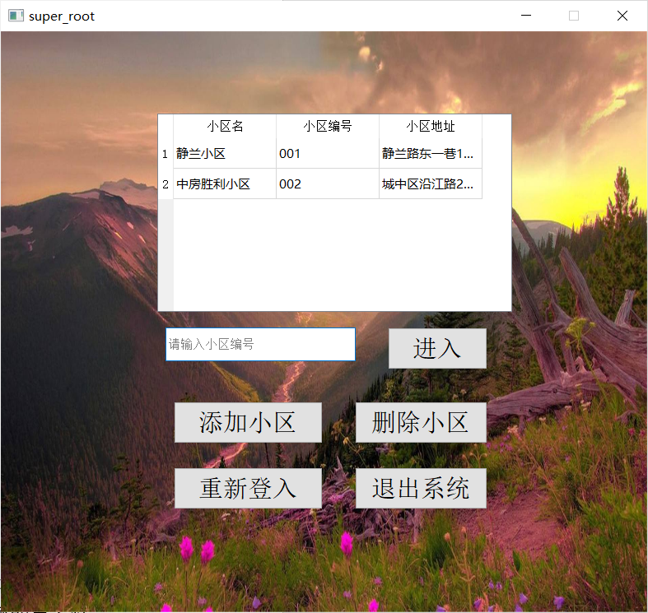

1.1.添加小区

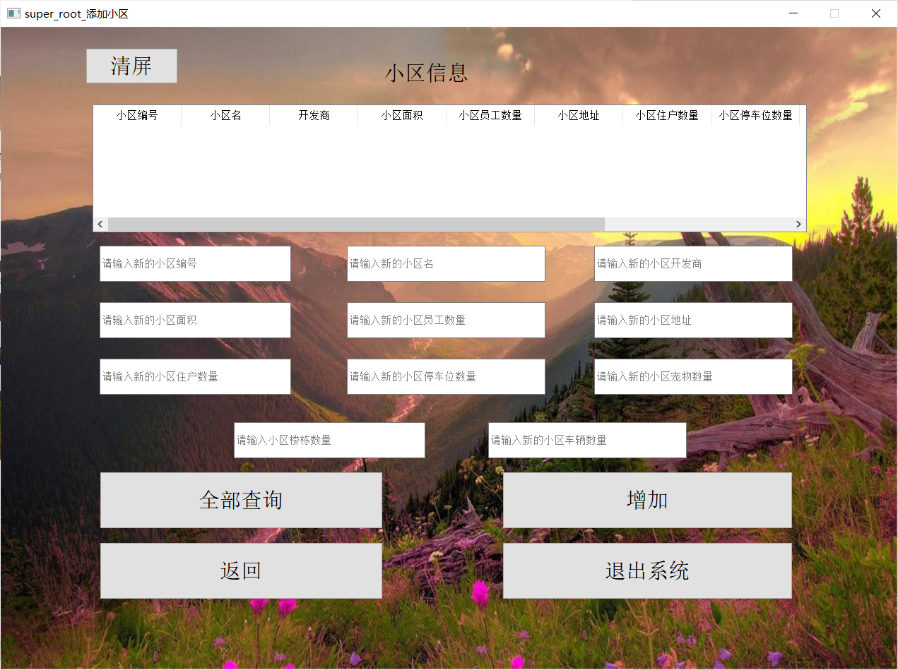

尝试添加小区

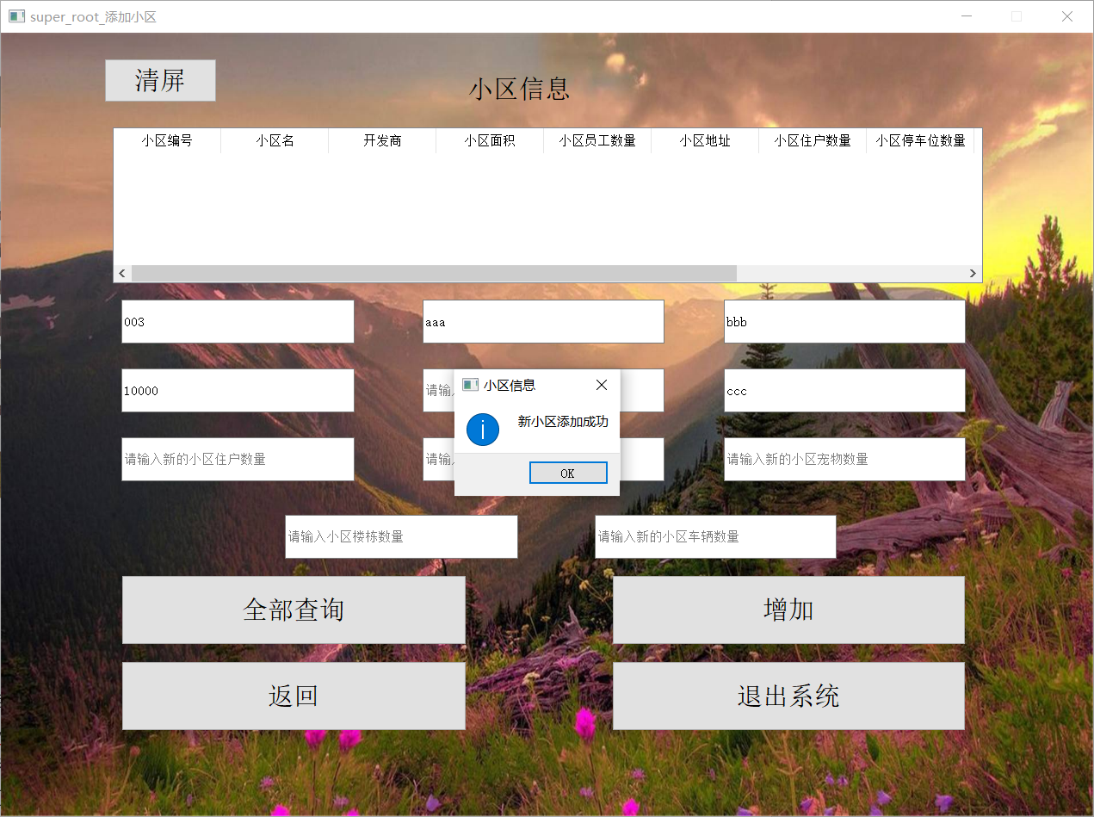

成功添加，尝试查询

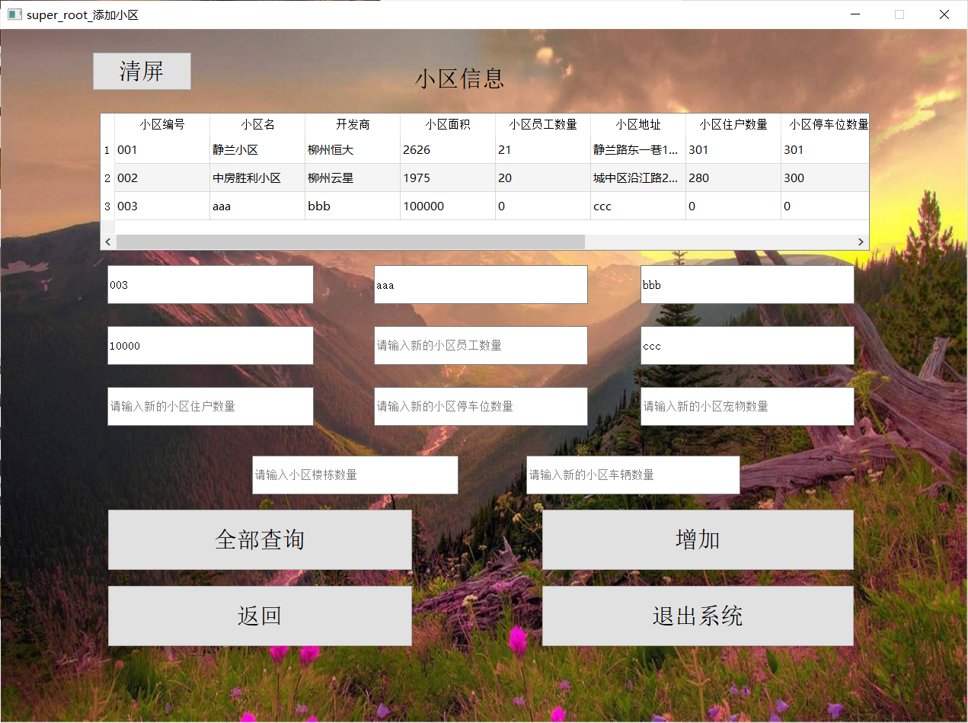

成功查询

1.2删除小区

尝试通过输入小区编号删除小区

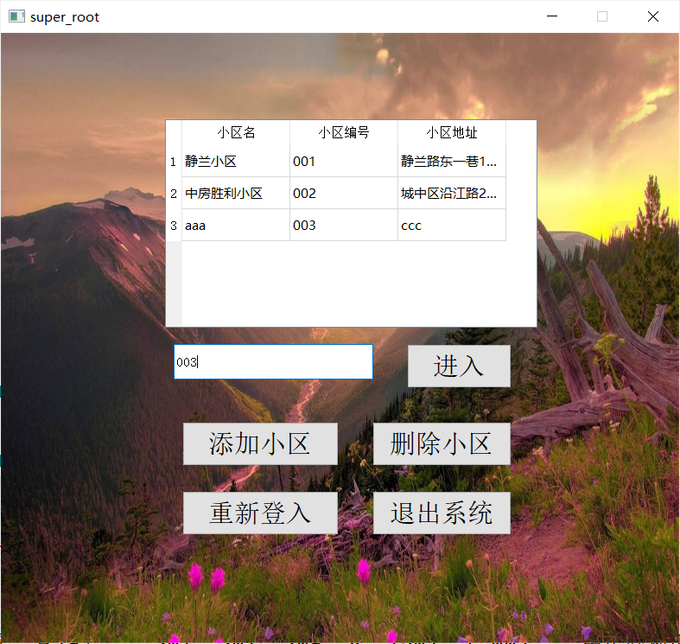

成功删除

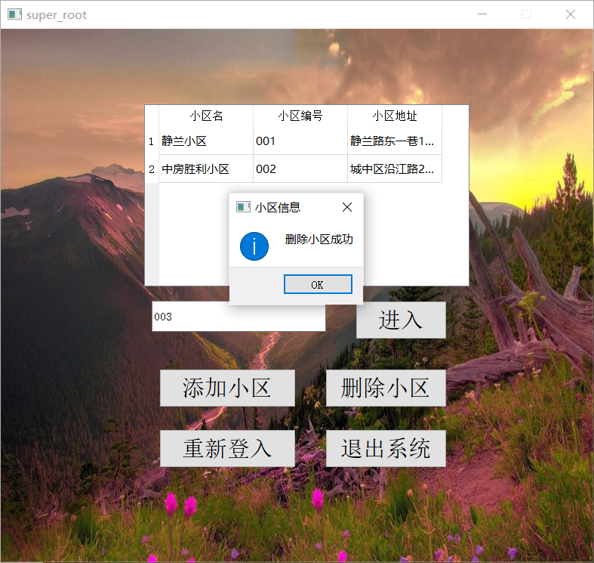

1.3 进入小区查看具体的小区信息

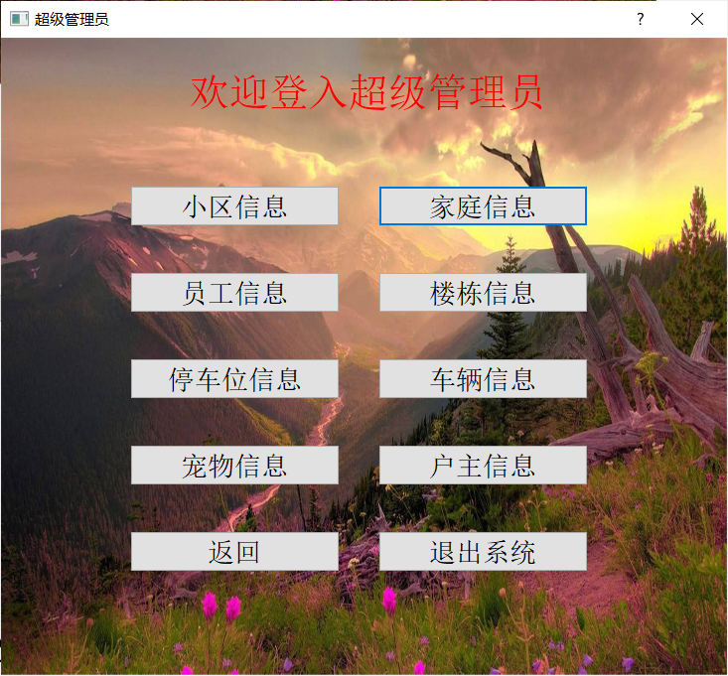

1.4 查看小区信息

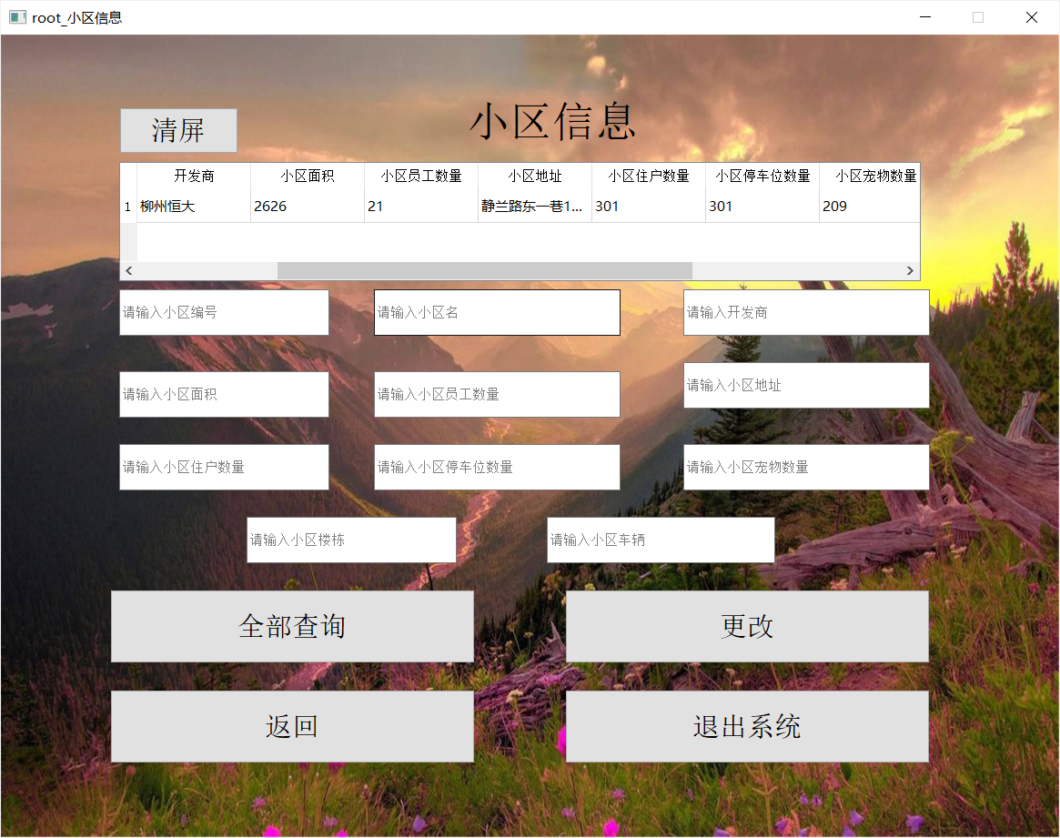

1.5 查看家庭信息

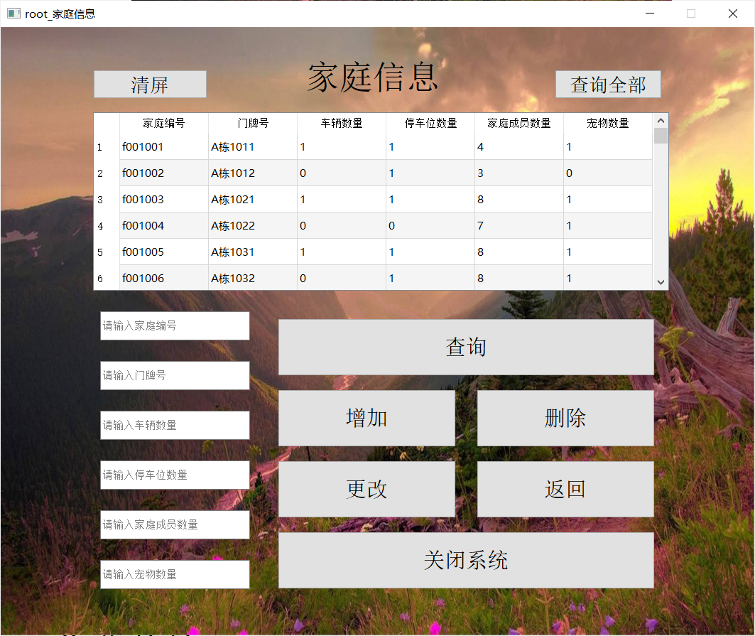

1.6 根据检索值查询家庭信息

检索车辆数量，停车位数量，宠物数量均为1的家庭

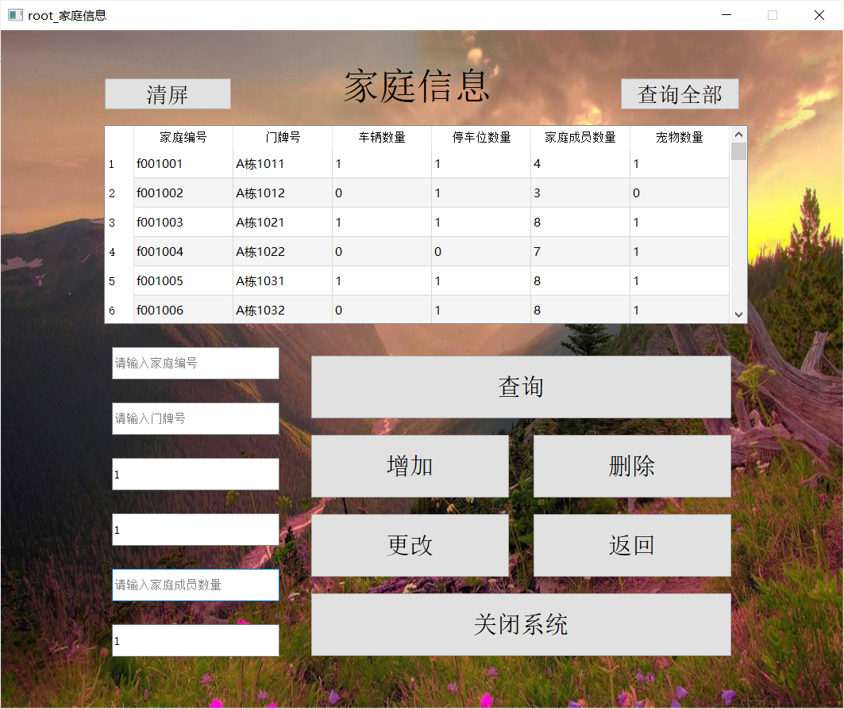

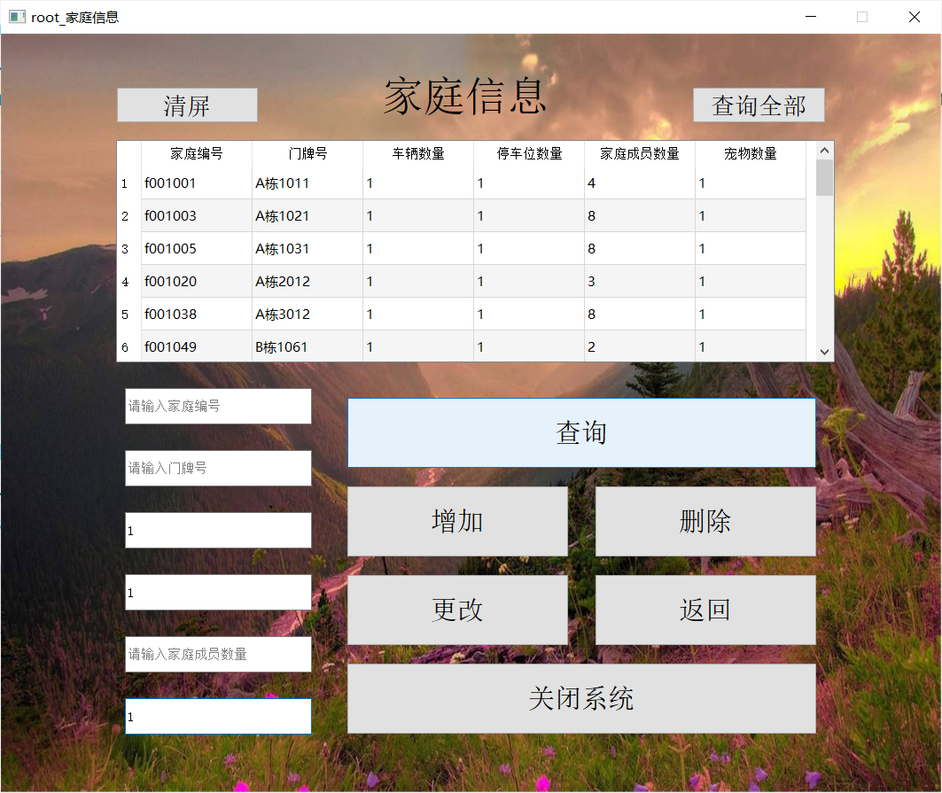

查询成功，成功输出车辆数量，停车位数量，宠物数量均为1的家庭

1.7 查看当前小区的员工信息

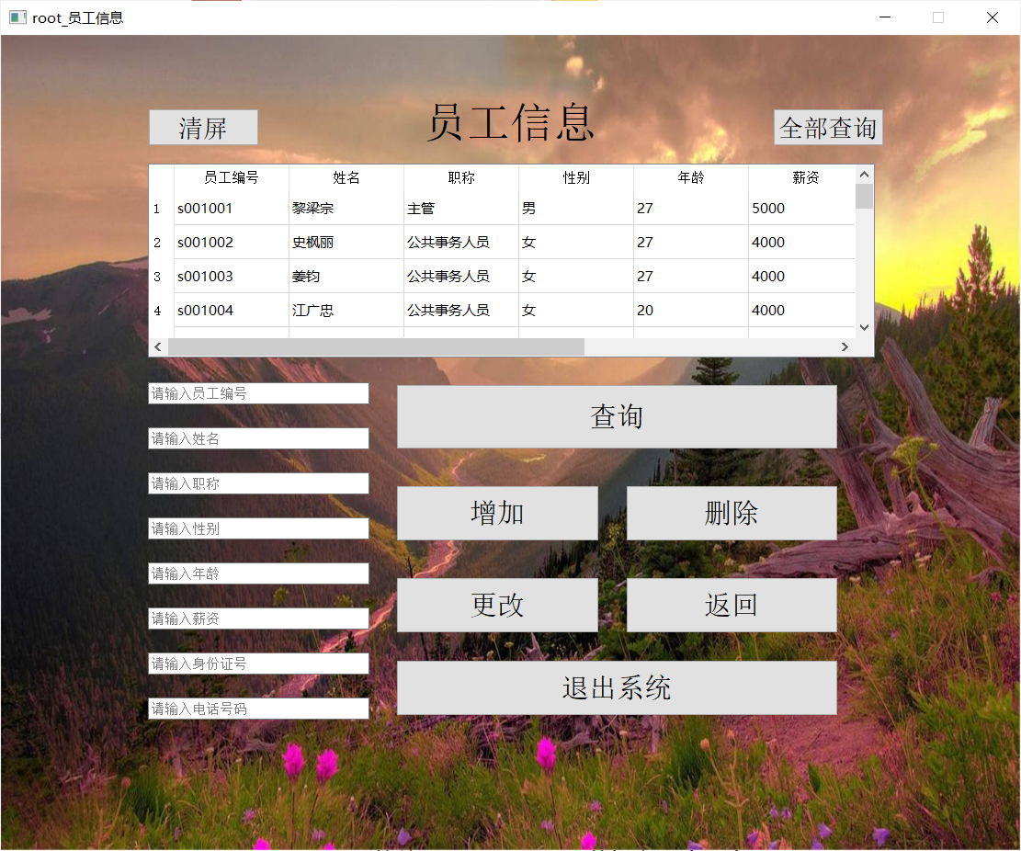

1.8 查询当前小区楼栋信息

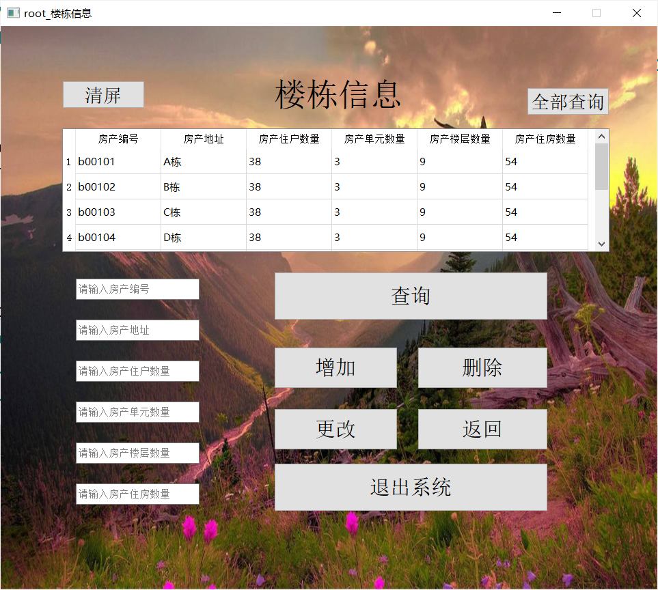

1.9 增加楼栋信息

其中房产编号为b00109，房产地址为I栋，房产住户数量为40，房产单元数量为3，房产楼层数量为10，房产住房数量为0

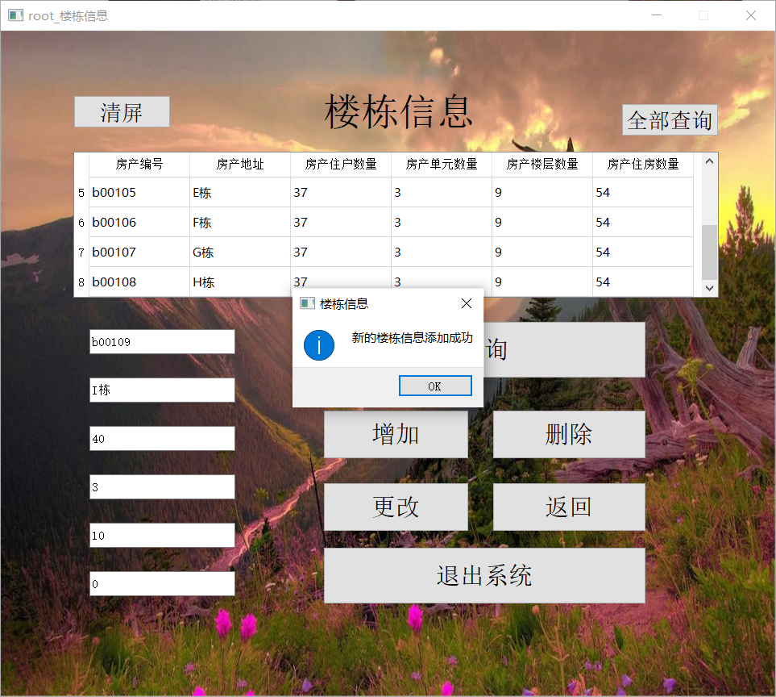

1.10 修改楼栋信息

将刚刚新增的房产编号为b00109的楼栋的住房数量修改为50

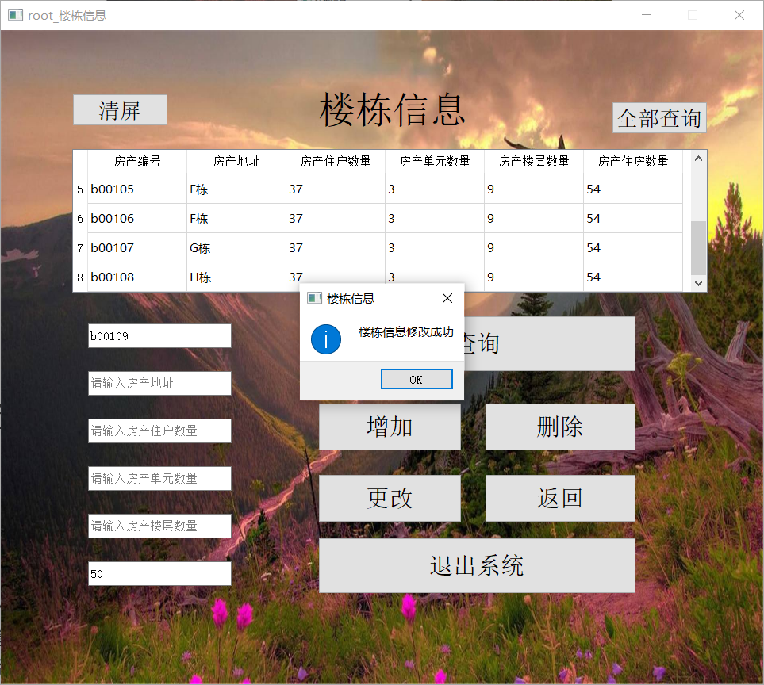

1.11 查询停车位信息

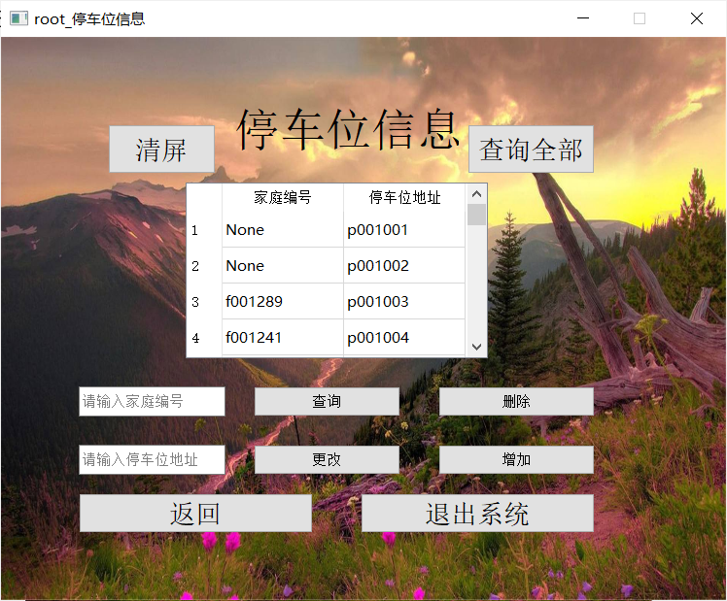

1.12 查询车辆信息

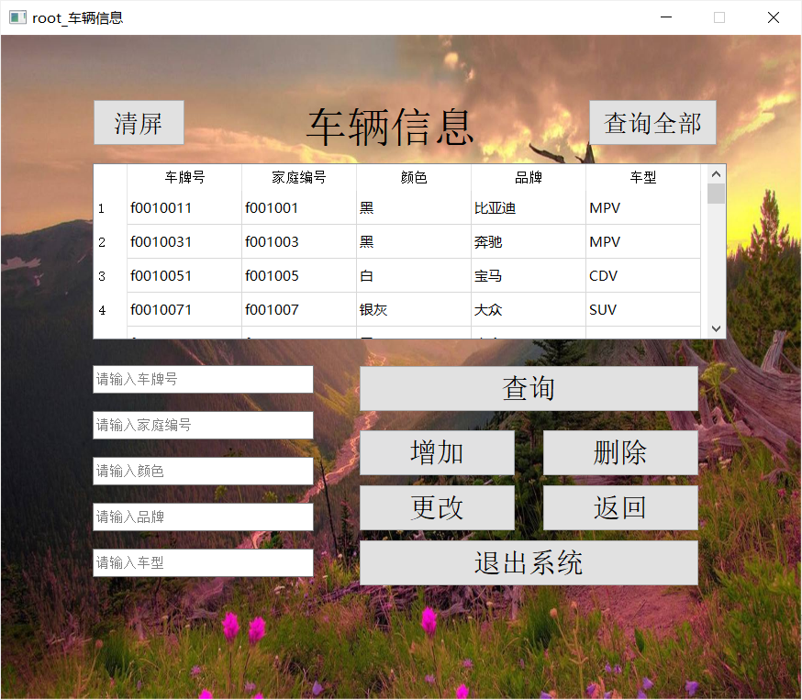

1.13 查询宠物信息

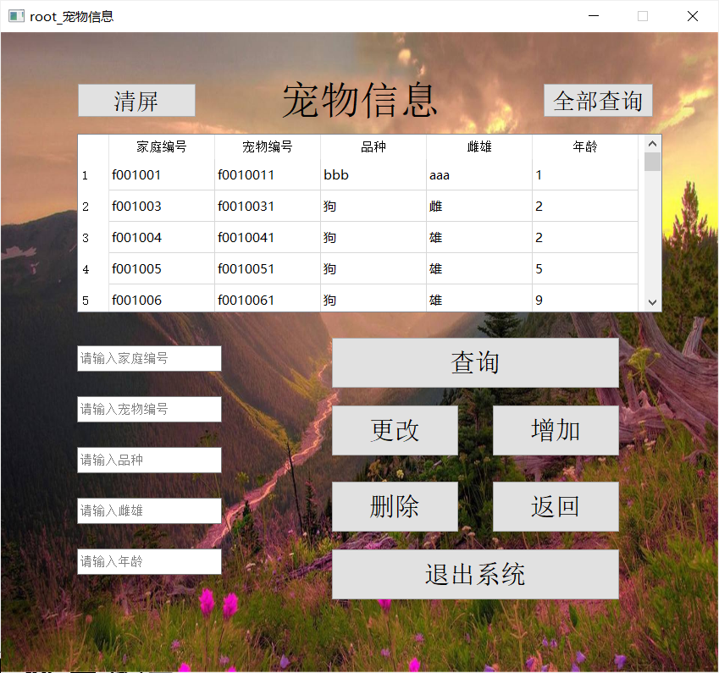

1.14 查询户主信息

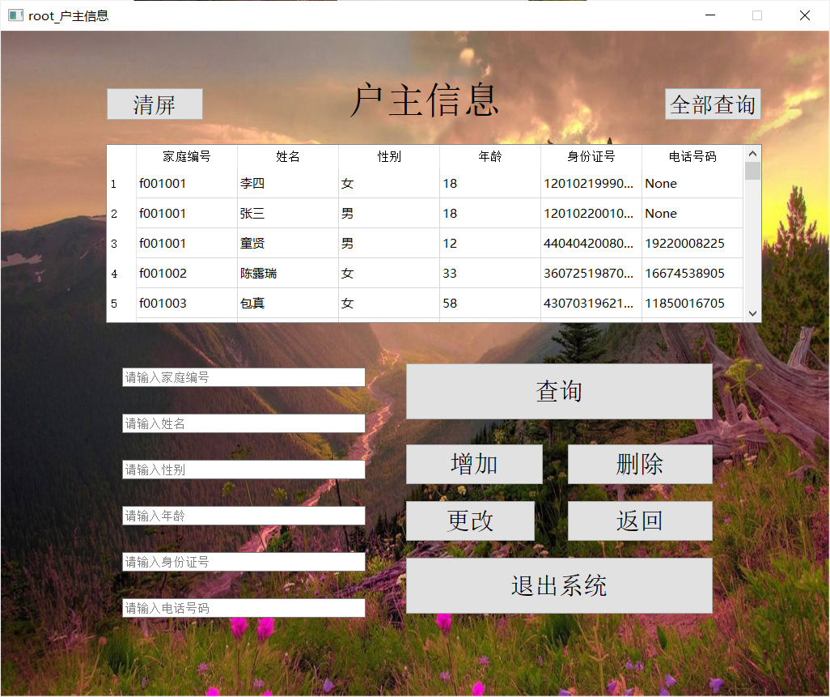

## 5.2 普通管理员测试

普通管理员进入系统后将直接进入小区信息详细管理界面，不能进行选择小区且只能看到自己所管理的小区，不能增加与删除小区信息，其余功能与超级管理员相同。

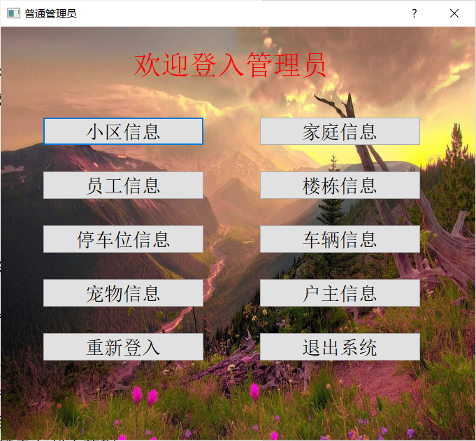

## 5.3 用户测试

用户拥有自己不同于管理员的独立界面，用户仅能查看部分信息且无权对信息进行修改、增加、删除。

1.1 用户界面

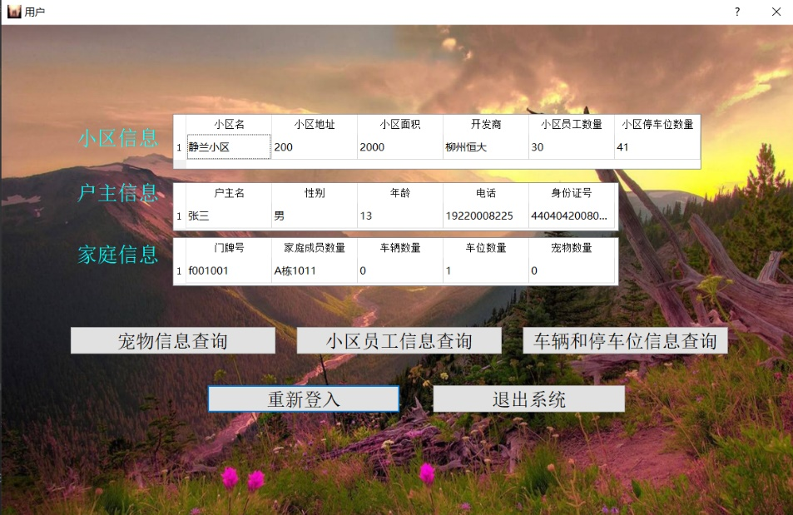

* 1. 宠物信息

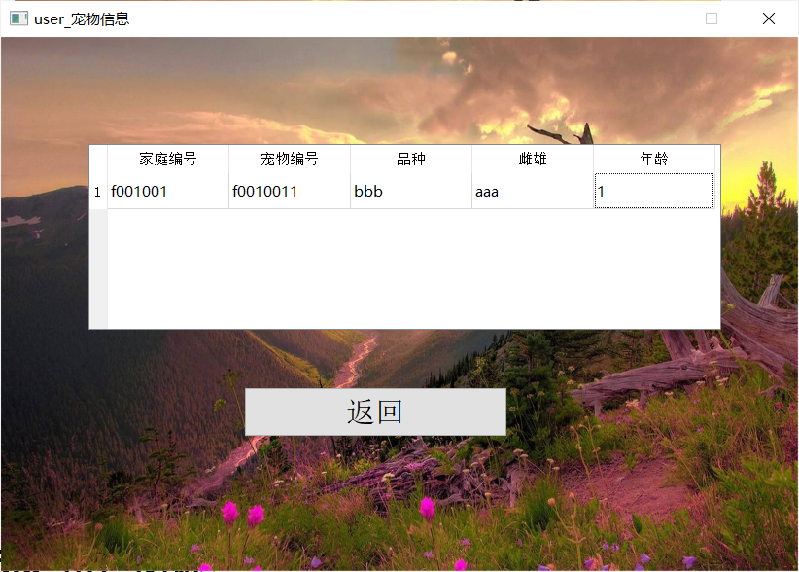

* 1. 小区员工信息

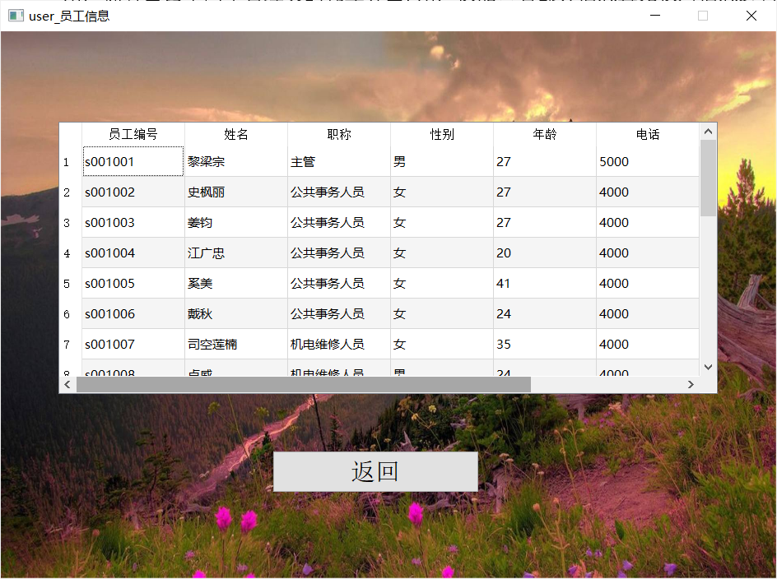

* 1. 车辆与停车位信息

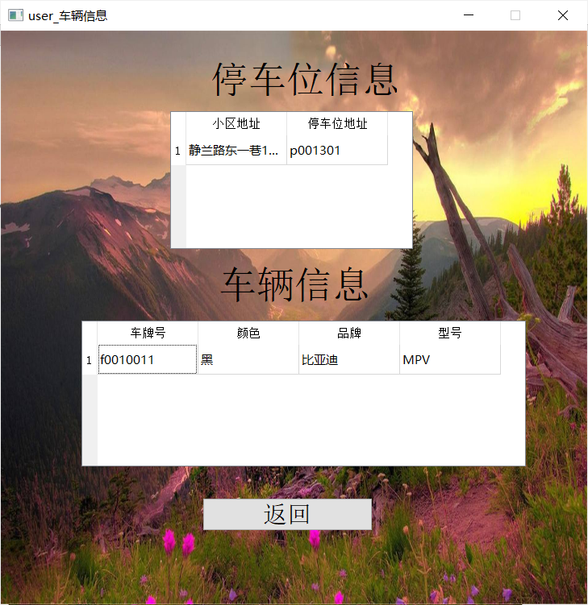

# 6作业总结

通过这次的《物业公司管理系统》数据库课程设计，我们学习并掌握了pyqt5 designer、pycharm、pymysql、mysql的简单使用 ，了解到了数据库设计在计算机领域的重要性。数据库作为一个永久存储形式在应用中发挥着重要的作用。

对于数据库的设计，应先做好需求分析和功能设计，设计好E-R图后根据E-R图转换的关系模式建立基本表。连接数据库，程序源代码与数据库的联系都很重要。此外还掌握概念关系数据模型的数据结构和基本术语，关系模型的完整性约束和关系代数运算。重点是关系模式完整性的分类和功能，以及关系代数中集合运算和关系运算。 对集成环境、一些控件的使用和界面的美化方面更加熟悉。因为《物业公司管理系统》中涉及到很多控件的使用，只有很好的使用这些控件才可以给出一个很好的界面呈现在用户的面前。这样更有利于数据库和用户之间的交流

# 附 录

## 数据库操作部分的Python代码

**import** pymysql  
**from** PyQt5 **import** *  
**import** sys  
**from** PyQt5.QtWidgets **import** *  
**from** login **import** *  
  
*#链接数据库*conn = pymysql.connect(  
 host=**'localhost'**,  
 port=25500,  
 user=**'root'**,  
 password=**'75121120'**,  
 database=**'ssh_crud'**,  
 charset=**'utf8'**)  
cursor = conn.cursor()  
  
*#登陆***def** sql_login(a, b):  
 *#定义变量* value1 = (a,)  
 value2 = (b,)  
 table = [**'admin'**, **'family_account_number'**, **'staff_account_number'**]  
 flag = 0  
 sql1 = **"select id from admin"** sql2 = **"select id from family_account_number"** sql3 = **"select id from staff_account_number"** *#从数据库中查询信息* cursor.execute(sql1)  
 ret1 = cursor.fetchall()  
 cursor.execute(sql2)  
 ret2 = cursor.fetchall()  
 cursor.execute(sql3)  
 ret3 = cursor.fetchall()  
  
 *#判断登陆的用户的用户类型  
 #超级管理员* **for** myret1 **in** ret1:  
 **if** value1 == myret1:  
 flag = 1  
 user = 0  
 **break** *#用户* **if** flag == 0:  
 **for** myret2 **in** ret2:  
 **if** value1 == myret2:  
 flag = 2  
 user = 2  
 **break** *#普通管理员* **if** flag == 0:  
 **for** myret3 **in** ret3:  
 **if** value1 == myret3:  
 flag = 3  
 user = 1  
 **break** *#查询并获取密码* sql4 = **"select password from "** + table[flag-1] + **" where(id = \'"** + a + **"\');"** cursor.execute(sql4)  
 ret = cursor.fetchone()  
  
 *#判断是否登陆成功* conn.commit()  
 **if** flag == 0:  
 **return** 0, -1*#用户名不存在* **if** value2 == ret:  
 **return** 2, user*#登陆成功，user为整型值，0，1，2对应超级管理员，普通管理员，用户* **else**:  
 **return** 1, -1*#密码错误  
  
  
#修改密码***def** sql_change_password(a, b, c, d):  
 *#定义变量* cursor = conn.cursor()  
 value1 = (a,)  
 value2 = (b,)  
 value3 = (c,)  
 value4 = (d,)  
 table_number = 0  
 table = [**'admin'**, **'family_account_number'**, **'staff_account_number'**]  
 sql1 = **"select id from admin"** sql2 = **"select id from family_account_number"** sql3 = **"select id from staff_account_number"** *#从数据库读取数据* cursor.execute(sql1)  
 ret1 = cursor.fetchall()  
 cursor.execute(sql2)  
 ret2 = cursor.fetchall()  
 cursor.execute(sql3)  
 ret3 = cursor.fetchall()  
  
 *#判断尝试登陆的是哪个用户* **for** myret1 **in** ret1:  
 **if** value1 == myret1 :  
 table_number = 1  
 **break  
 if** table_number == 0:  
 **for** myret2 **in** ret2:  
 **if** value1 == myret2:  
 table_number = 2  
 **break  
 if** table_number == 0:  
 **for** myret3 **in** ret3:  
 **if** value1 == myret3:  
 table_number = 3  
 **break** *#寻找密码的mysql语句* sql4 = **"select password from "** + table[table_number-1] + **" where(id = \'"** + a + **"\');"** *#从数据库中寻找密码* cursor.execute(sql4)  
 ret = cursor.fetchone()  
  
 *#修改密码语句* sql5 = **"update "** + table[table_number - 1] + **" set password = \'"** + c + **"\' where id = \'"** + a + **"\';"** *#根据不同状态返回值* **if** table_number == 0 :  
 **return** 0 *#用户名不存在* **if** value2 != ret:  
 **return** 1*#密码错误* **if** value2 == ret :  
 **if** value3 == value4 :  
 cursor.execute(sql5)  
 conn.commit()  
 **return** 3 *#修改成功* **else**:  
 **return** 2 *#密码不一致  
  
#判断用户与普通管理员所在的小区***def** sql_judge_h_e(a):*#参数a为用户名  
 # 查询用户所在小区,h_e_id为小区编号* query_id0 = **"select staff.h_e_id from staff,staff_account_number where "** \  
 **"staff.id = staff_account_number.staff_id "** \  
 **"and staff_account_number.staff_id = \'"** + a + **"\';"** query_id1 = **"select family.h_e_id from family,family_account_number where "** \  
 **"family.id = family_account_number.f_id "** \  
 **"and family_account_number.f_id = \'"** + a + **"\';"  
 if** a[0] == **'s'**:  
 cursor.execute(query_id0)  
 h_e_id = cursor.fetchone()  
 **elif** a[0] == **'f'**:  
 cursor.execute(query_id1)  
 h_e_id = cursor.fetchone()  
 **return** h_e_id[0]  
  
*#查询小区信息***def** sql_query_h_e(a, b):*# a = 用户名 , b = 返回的身份。0，1，2对应超级管理员，普通管理员，用户* print(1111)  
 print(b)  
 print(1111)  
 *#查询用户所在小区,h_e_id为小区编号* query_id0 = **"select staff.h_e_id from staff,staff_account_number where "** \  
 **"staff.id = staff_account_number.staff_id "** \  
 **"and staff_account_number.staff_id = \'"** + a + **"\';"** query_id1 = **"select family.h_e_id from family,family_account_number where "** \  
 **"family.id = family_account_number.f_id "** \  
 **"and family_account_number.f_id = \'"** + a + **"\';"  
  
 if** b == 0:  
 h_e_id = (**'0'**,)  
 **elif** b == 1:  
 cursor.execute(query_id0)  
 h_e_id = cursor.fetchone()  
 **elif** b == 2:  
 cursor.execute(query_id1)  
 h_e_id = cursor.fetchone()  
 **else**:  
 **return** -1, -1  
 *#定义sql查询语句* sql0 = **"select id, h_e_name, h_e_developer, h_e_area, h_e_staff, h_e_adress, h_e_family, h_e_parking, h_e_pet, h_e_building, h_e_car"** \  
 **"from housing_estate;"** sql1 = **"select id,h_e_name,h_e_developer,h_e_area,h_e_staff,h_e_adress,h_e_family,h_e_parking,h_e_pet,h_e_building,h_e_car"** \  
 **"from housing_estate where id = \'"** + h_e_id[0] + **"\';"** sql2 = **"select "** \  
 **"h_e_name,h_e_adress,h_e_area,h_e_developer,h_e_staff,h_e_parking "** \  
 **"from housing_estate where id = \'"** + h_e_id[0] + **"\';"** *#超级管理员* **if** b == 0:  
 cursor.execute(sql0)  
 row = cursor.execute(sql0)  
 ret = cursor.fetchall()  
 *#普通管理员* **elif** b == 1:  
 cursor.execute(sql1)  
 row = cursor.execute(sql1)  
 ret = cursor.fetchall()  
 *#用户* **elif** b == 2:  
 cursor.execute(sql2)  
 row = cursor.execute(sql2)  
 ret = cursor.fetchall()  
 conn.commit()  
 **return** ret, row  
  
*#用户查看自己的户主信息***def** sql_query_f_people(a):*#参数a为用户名* sql = **"select pname,psex,page,pphone,id from people where f_id = \'"** + a + **"\';"** cursor.execute(sql)  
 row = cursor.execute(sql)  
 ret = cursor.fetchone()  
 **return** ret, row  
*#用户查看自己的家庭信息***def** sql_query_f_family(a):*#参数a为用户名* sql = **"select id,family_number,car,parking,pet from family where id = \'"** + a + **"\';"** cursor.execute(sql)  
 row = cursor.execute(sql)  
 ret = cursor.fetchone()  
 **return** ret, row  
*#用户查看自己的宠物信息***def** sql_query_f_pet(a):*#参数a用户名  
 #定义数据库查询语句* sql = **"select f_id,pet.id,variety,sex,age from pet,family where pet.f_id = family.id and family.id = \'"** + a + **"\';"** cursor.execute(sql)  
 ret = cursor.fetchall()  
 row = cursor.execute(sql)  
 conn.commit()  
 *#返回元组ret(若用户没有宠物则返回空元组)* **return** ret, row  
*#用户查询车辆信息***def** sql_query_f_car(a):*#参数a用户名  
 #定义数据库查询语句* sql = **"select car.id,color,brand,model from car,family where car.f_id = family.id and family.id = \'"** + a + **"\';"** cursor.execute(sql)  
 row = cursor.execute(sql)  
 ret = cursor.fetchall()  
 conn.commit()  
 **return** ret, row*#返回元组ret(若用户没有车辆则返回空元组)  
#用户查看自己的小区车位信息***def** sql_query_f_parking(a):*#参数a为用户名  
 #定义数据库语句* sql = **"select housing_estate.h_e_adress,parking.adress from parking,housing_estate,family"** \  
 **" where( housing_estate.id = (select family.h_e_id where family.id = \'"** + a + **"\') and parking.f_id = \'"** + a + **"\');"** cursor.execute(sql)  
 row = cursor.execute(sql)  
 ret = cursor.fetchall()  
 **return** ret, row*#返回元组ret(若用户没有车辆则返回空元组)  
#用户查看自己小区的员工信息***def** sql_query_f_staff(a):*#参数a为小区id* sql = **"select staff.id,s_name,staff_position,s_sex,s_age,wages,idcard,telephone "** \  
 **"from staff,housing_estate "** \  
 **"where( staff.h_e_id = housing_estate.id and staff.h_e_id = \'"** + a + **"\');"** cursor.execute(sql)  
 row = cursor.execute(sql)  
 ret = cursor.fetchall()  
 conn.commit()  
 **return** ret, row  
  
  
*#超级管理员选择小区***def** sql_select_super_root_h_e(a):*#参数a为用户输入的值* sql1 = **"select id from housing_estate where id = \'"** + a[0] + **"\';"** cursor.execute(sql1)  
 x = cursor.fetchone();  
 **if not** x:  
 **return** 0 *#未找到对应的小区* **return** x[0] *#返回小区编号  
  
#超级管理员查看所有小区***def** sql_query_super_root_h_e():  
 sql = **"select h_e_name,id,h_e_adress from housing_estate;"** cursor.execute(sql)  
 row = cursor.execute(sql)  
 ret = cursor.fetchall()  
 **return** ret, row  
  
*#超级管理员添加小区查看所有小区信息***def** sql_query_super_root_add_community():  
 sql = **"select id,h_e_name,h_e_developer,h_e_area,h_e_staff,h_e_adress,"** \  
 **"h_e_family,h_e_parking,h_e_pet,h_e_building,h_e_car "** \  
 **"from housing_estate;"** cursor.execute(sql)  
 row = cursor.execute(sql)  
 ret = cursor.fetchall()  
 **return** ret, row  
  
*#超级管理员增加小区***def** sql_add_super_root_h_e(a):*#参数a为用户输入的值, 小区编号，小区地址，小区开发商，小区名，小区面积不能为空值，小区员工数量，  
 #小区家庭数量，小区停车场数量，小区宠物数量，小区楼栋数量，小区车辆数量均默认为零且增加时不支持赋值* column = (**"id"**,**"h_e_name"**,**"h_e_developer"**,**"h_e_area"**,**"h_e_staff"**,**"h_e_adress"**,  
 **"h_e_family"**,**"h_e_parking"**,**"h_e_pet"**,**"h_e_building"**,**"h_e_car"**)  
 temp = (a[0],a[5],a[2],a[3],a[8],a[6],a[10],a[4],a[9],a[7],a[1])  
 sql2 = **"select id from housing_estate where id = \'"** + temp[0] + **"\';"** cursor.execute(sql2)  
 x = cursor.fetchone()  
 conn.commit()  
 **if** x:  
 **return** 0 *# 该小区已经存在* sql1 = **"insert into housing_estate values("  
 for** i **in** temp:  
 **if** temp.index(i) == 3:  
 **if** i != -1:  
 sql1 = sql1 + str(i) + **"0,"  
 else**:  
 sql1 = sql1 + **"0,"  
 elif** temp.index(i) == 5:  
 **if** i != -1:  
 sql1 = sql1 + str(i) + **"0,"  
 else**:  
 sql1 = sql1 + **"0,"  
 elif** temp.index(i) == 6:  
 sql1 = sql1 + **"0,"  
 elif** temp.index(i) == 7:  
 sql1 = sql1 + **"0,"  
 elif** temp.index(i) == 8:  
 sql1 = sql1 + **"0,"  
 elif** temp.index(i) == 9:  
 sql1 = sql1 + **"0,"  
 elif** temp.index(i) == 4:  
 sql1 = sql1 + **"0,"  
 elif** temp.index(i) == 9:  
 sql1 = sql1 + **"0,"  
 else** :  
 sql1 = sql1 + **"\'"** + i + **"\',"** sql1 = sql1[:-1] + **");"** cursor.execute(sql1)  
 conn.commit()  
 **return** 1 *# 成功插入  
  
  
#超级管理员删除小区***def** sql_del_super_root_h_e(a):*#参数a为用户输入的值,其中小区编号不能为空* sql1 = **"select id from housing_estate where id = \'"** + a[0] + **"\';"** cursor.execute(sql1)  
 x = cursor.fetchone()  
 **if not** x:  
 **return** 0 *# 不存在该用户* sql2 = **"delete from housing_estate where id = \'"** + a[0] + **"\';"** cursor.execute(sql2)  
 conn.commit()  
 **return** 1 *# 删除成功  
  
  
  
  
#管理员查看当前小区所有户主信息***def** sql_query_root_people_owner(a):*#参数a为小区id* sql = **"select people.f_id,people.pname,people.psex,people.page,people.id,people.pphone "** \  
 **"from people,family where people.f_id = family.id and family.h_e_id = \'"** + a + **"\';"** print(sql)  
 cursor.execute(sql)  
 row = cursor.execute(sql)  
 ret = cursor.fetchall()  
 conn.commit()  
 **return** ret ,row  
*#管理员根据检索值查看户主信息***def** sql_query_root_p_search(a,b):*#参数a为用户输入的索引值，参数b为小区id* sql = **"select f_id,pname,psex,page,people.id,pphone from "** \  
 **"people,family where(people.f_id = family.id and family.h_e_id = \'"** + b + **"\' and "** column = (**"people.f_id"**,**"people.pname"**,**"people.psex"**,**"people.page"**,**"people.id"**,**"people.pphone"**)  
 **for** i **in** a :  
 **if** i != -1:  
 **if** a.index(i) != 3 :  
 x = a.index(i)  
 sql = sql + column[x] + **" = \'"** + i + **"\' and "  
 elif** a.index(i) == 3:  
 x = a.index(i)  
 sql = sql + column[x] + **" = "** + str(i) + **" and "** sql = sql[:-5]  
 sql = sql + **' );'** cursor.execute(sql)  
 row = cursor.execute(sql)  
 ret = cursor.fetchall()  
 conn.commit()  
 **return** ret ,row  
  
*#管理员查看当前小区所有楼栋信息***def** sql_query_root_building(a):*#参数a为小区id* sql = **"select building.id,building.b_adress,building.b_family,building.unit,building.floor,building.room "** \  
 **"from building,housing_estate where building.h_e_id = housing_estate.id and housing_estate.id = \'"** + a + **"\';"** cursor.execute(sql)  
 row = cursor.execute(sql)  
 ret = cursor.fetchall()  
 conn.commit()  
 **return** ret, row  
*#管理员根据检索值查看当前小区的楼栋信息***def** sql_query_root_b_search(a,b):*#参数a为用户输入的索引值，参数b为小区id* sql = **"select building.id,b_adress,b_family,unit,floor,room "** \  
 **"from building,housing_estate where(building.h_e_id = housing_estate.id "** \  
 **"and housing_estate.id = \'"** + b + **"\' and "** column = (**"building.id"**, **"building.b_adress"**, **"building.b_family"**, **"building.unit"**, **"building.floor"**, **"building.room"**)  
 **for** i **in** a:  
 **if** i != -1:  
 **if** a.index(i) == 0 **or** a.index(i) == 1 :  
 x = a.index(i)  
 sql = sql + column[x] + **" = \'"** + i + **"\' and "  
 else** :  
 x = a.index(i)  
 sql = sql + column[x] + **" = "** + str(i) + **" and "** sql = sql[:-5]  
 sql = sql + **' );'** cursor.execute(sql)  
 row = cursor.execute(sql)  
 ret = cursor.fetchall()  
 conn.commit()  
 **return** ret, row  
  
*#管理员查看当前小区停车位信息***def** sql_query_root_parking(a):*#参数a为小区编号* sql = **"select f_id,adress from parking where h_e_id = \'"** + a + **"\';"** cursor.execute(sql)  
 row = cursor.execute(sql)  
 ret = cursor.fetchall()  
 conn.commit()  
 **return** ret, row  
*#管理员根据检索值查看当前小区停车位信息***def** sql_query_root_parking_search(a,b):*#参数a为用户输入的索引值，参数b为小区id* sql = **"select f_id,adress from parking where( h_e_id = \'"** + b + **"\' and "** column = (**"f_id"**, **"adress"**)  
 **for** i **in** a:  
 **if** i != -1:  
 x = a.index(i)  
 sql = sql + column[x] + **" = \'"** + i + **"\' and "** sql = sql[:-5]  
 sql = sql + **' );'** cursor.execute(sql)  
 row = cursor.execute(sql)  
 ret = cursor.fetchall()  
 conn.commit()  
 **return** ret,row  
  
*#管理员查看当前小区车辆信息***def** sql_query_root_car(a):*#参数a为小区id* sql = **"select car.id,f_id,color,brand,model from car,family "** \  
 **"where( car.f_id = family.id and family.h_e_id = \'"** + a + **"\');"** cursor.execute(sql)  
 row = cursor.execute(sql)  
 ret = cursor.fetchall()  
 conn.commit()  
 **return** ret, row  
*#管理员根据检索值查看当前小区车辆信息***def** sql_query_root_car_search(a,b):*#参数a为用户输入的索引值，参数b为小区id* sql = **"select car.id,f_id,color,brand,model from car,family "** \  
 **"where( car.f_id = family.id and family.h_e_id = \'"** + b + **"\' and "** column = (**"car.id"**, **"f_id"**,**"color"**,**"brand"**,**"model"**)  
 **for** i **in** a :  
 **if** i != -1:  
 x = a.index(i)  
 sql = sql + column[x] + **" = \'"** + i + **"\' and "** sql = sql[:-5]  
 sql = sql + **' );'** cursor.execute(sql)  
 row = cursor.execute(sql)  
 ret = cursor.fetchall()  
 conn.commit()  
 **return** ret, row  
  
*#管理员查看当前小区所有的宠物信息***def** sql_query_root_pet(a):*#参数a为小区id* sql = **"select f_id,pet.id,variety,sex,age from pet,family "** \  
 **"where( pet.f_id = family.id and family.h_e_id = \'"** + a + **"\');"** cursor.execute(sql)  
 row = cursor.execute(sql)  
 ret = cursor.fetchall()  
 conn.commit()  
 **return** ret, row  
*#管理员根据检索值查看当前小区的宠物信息***def** sql_query_root_pet_search(a,b):*#参数a为用户输入的索引值，参数b为小区id* sql = **"select f_id,pet.id,variety,sex,age from pet,family "** \  
 **"where( pet.f_id = family.id and family.h_e_id = \'"** + b + **"\' and "** column = (**"f_id"**, **"pet.id"**, **"variety"**, **"sex"**, **"age"**)  
 **for** i **in** a :  
 **if** i != -1:  
 **if** a.index(i) != 4:  
 x = a.index(i)  
 sql = sql + column[x] + **" = \'"** + i + **"\' and "  
 else** :  
 x = a.index(i)  
 sql = sql + column[x] + **" = "** + str(i) + **" and "** sql = sql[:-5]  
 sql = sql + **' );'** cursor.execute(sql)  
 row = cursor.execute(sql)  
 ret = cursor.fetchall()  
 conn.commit()  
 **return** ret, row  
  
*#管理员查看当前小区的所有员工信息***def** sql_query_root_staff(a):*#参数a为小区id* sql = **"select staff.id,s_name,staff_position,s_sex,s_age,wages,idcard,telephone "** \  
 **"from staff,housing_estate "** \  
 **"where( staff.h_e_id = housing_estate.id and staff.h_e_id = \'"** + a + **"\');"** cursor.execute(sql)  
 row = cursor.execute(sql)  
 ret = cursor.fetchall()  
 conn.commit()  
 **return** ret, row  
*#管理员根据检索值查看当前小区的员工信息***def** sql_query_root_staff_search(a,b):*#参数a为用户输入的索引值，参数b为小区id* sql = **"select staff.id,s_name,staff_position,s_sex,s_age,wages,idcard,telephone "** \  
 **"from staff,housing_estate "** \  
 **"where( staff.h_e_id = housing_estate.id and staff.h_e_id = \'"** + b + **"\' and "** column = (**"staff.id"**, **"s_name"**, **"staff_position"**, **"s_sex"**, **"s_age"**,**"wages"**,**"idcard"**,**"telephone"**)  
 **for** i **in** a :  
 **if** i != -1:  
 **if** a.index(i) == 4 **or** a.index(i) == 5:  
 x = a.index(i)  
 sql = sql + column[x] + **" = "** + str(i) + **" and "  
 else** :  
 x = a.index(i)  
 sql = sql + column[x] + **" = \'"** + i + **"\' and "** sql = sql[:-5]  
 sql = sql + **' );'** cursor.execute(sql)  
 row = cursor.execute(sql)  
 ret = cursor.fetchall()  
 conn.commit()  
 **return** ret, row  
  
*#管理员查看当前小区的所有家庭信息***def** sql_query_root_family(a):*#参数a为小区id* sql = **"select family.id,family_number,car,parking,people,pet "** \  
 **"from family,housing_estate "** \  
 **"where(family.h_e_id = housing_estate.id and family.h_e_id = \'"** + a + **"\');"** cursor.execute(sql)  
 row = cursor.execute(sql)  
 ret = cursor.fetchall()  
 conn.commit()  
 **return** ret, row  
*#管理员根据检索值查看当前小区的家庭信息***def** sql_query_root_family_search(a,b):*#参数a为用户输入的索引值，参数b为小区id* sql = **"select family.id,family_number,car,parking,people,pet "** \  
 **"from family,housing_estate "** \  
 **"where(family.h_e_id = housing_estate.id and family.h_e_id = \'"** + b + **"\' and "** column = (**"family.id"**, **"family_number"**, **"car"**, **"parking"**, **"people"**, **"pet"**)  
 print(a)  
 **for** i **in** a :  
 print(a.index(i))  
 print(1)  
 **if** i != -1:  
 **if** a.index(i) == 0:  
 x = a.index(i)  
 sql = sql + column[x] + **" = \'"** + i + **"\' and "  
 elif** a.index(i) == 1:  
 x = a.index(i)  
 sql = sql + column[x] + **" = \'"** + i + **"\' and "  
 else** :  
 x = a.index(i)  
 sql = sql + column[x] + **" = "** + str(i) + **" and "** sql = sql[:-5]  
 sql = sql + **' );'** sql = **"select family.id,family_number,car,parking,people,pet "** \  
 **"from family,housing_estate "** \  
 **"where(family.h_e_id = housing_estate.id and family.h_e_id = '001' and car = 1 and parking = 1 and pet = 1);"** print(sql)  
 cursor.execute(sql)  
 row = cursor.execute(sql)  
 ret = cursor.fetchall()  
 conn.commit()  
 **return** ret, row  
  
*#管理员查看小区信息***def** sql_query_root_h_e_infor(a):*#参数a为小区编号* sql = **"select id,h_e_name,h_e_developer,h_e_area,h_e_staff,h_e_adress,"** \  
 **"h_e_family,h_e_parking,h_e_pet,h_e_building,h_e_car "** \  
 **"from housing_estate where id = \'"** + a + **"\';"** cursor.execute(sql)  
 row = cursor.execute(sql)  
 ret = cursor.fetchall()  
 **return** ret, row  
  
*#管理员根据用户输入的信息修改小区信息，只支持修改小区名，小区开发商，小区面积，小区地址***def** sql_change_housing_estate(a): *#参数a为用户输入的值 , 其中小区编号不能为空* column = (**"id"**, **"h_e_name"**, **"h_e_developer"**, **"h_e_area"**, **"h_e_staff"**, **"h_e_adress"**,  
 **"h_e_family"**, **"h_e_parking"**, **"h_e_pet"**, **"h_e_building"**, **"h_e_car"**)  
 temp = (a[0],a[5],a[2],a[3],a[8],a[6],a[10],a[4],a[9],a[7],a[1])  
 column1 = (column[0],column[5],column[2],column[3],column[8],column[6],column[10]  
 ,column[4],column[9],column[7],column[1])  
 sql1 = **"select id from housing_estate where id = \'"** + a[0] + **"\';"** cursor.execute(sql1)  
 x = cursor.fetchone()  
 **if not** x:  
 **return** 0 *# 不存在该小区* sql2 = **"update housing_estate set "  
 for** i **in** temp:  
 **if** i != -1:  
 **if** temp.index(i) != 0:  
 **if** temp.index(i) == 1:  
 sql2 = sql2 + column1[temp.index(i)] + **"= \'"** + i + **"\', "  
 elif** temp.index(i) == 2:  
 sql2 = sql2 + column1[temp.index(i)] + **"= \'"** + i + **"\', "  
 elif** temp.index(i) == 10:  
 sql2 = sql2 + column1[temp.index(i)] + **"= \'"** + i + **"\', "  
 else**:  
 sql2 = sql2 + column1[temp.index(i)] + **" = "** + str(i) + **", "** sql2 = sql2[:-2] + **" where id = \'"** + temp[0] + **"\';"** cursor.execute(sql2)  
 conn.commit()  
 **return** 1 *# 修改成功  
  
  
  
#管理员增加户主信息***def** sql_add_people(a):*#参数a为用户输入的值，a中，除年龄与电话外，其余均不能为空值，空值用-1表示* column = (**"people.f_id"**, **"people.pname"**, **"people.psex"**, **"people.page"**, **"people.id"**, **"people.pphone"**)  
 temp = (a[4], a[0], a[1], a[2], a[3], a[5])  
 sql2 = **"select family.id from family,people where people.f_id = family.id and people.f_id = \'"** + temp[1] + **"\';"** cursor.execute(sql2)  
 x = cursor.fetchone()  
 **if not** x:  
 **return** 0*#找不到对应的家庭* sql4 = **"select people.id from people,family where people.f_id = family.id and people.f_id = \'"** + temp[1] + **"\';"** cursor.execute(sql4)  
 x = cursor.fetchone()  
 **if** x :  
 **return** 1*#该家庭已经存在户主* sql3 = **"select id from people where id = \'"** + temp[0] + **"\';"** cursor.execute(sql3)  
 x = cursor.fetchone()  
 conn.commit()  
 **if** x:  
 **return** 2*#该用户已经存在* sql1 = **"insert into people values("  
 for** i **in** temp:  
 **if** temp.index(i) == 4:  
 **if** i != -1:  
 sql1 = sql1 + str(i) + **","  
 else**:  
 sql1 = sql1 + **"null,"  
 elif** temp.index(i) == 5:  
 **if** i != -1:  
 sql1 = sql1 + **"\'"** + i + **"\',"  
 else**:  
 sql1 = sql1 + **"null,"  
 else**:  
 sql1 = sql1 + **"\'"** + i + **"\',"** sql1 = sql1[:-1] + **");"** cursor.execute(sql1)  
 conn.commit()  
 **return** 3*#成功插入  
#管理员删除户主信息***def** sql_del_people(a):*#参数a为用户输入的信息,其中身份证号不能为空* print(a)  
 column = (**"people.f_id"**, **"people.pname"**, **"people.psex"**, **"people.page"**, **"people.id"**, **"people.pphone"**)  
 sql1 = **"select id from people where id = \'"** + a[4] + **"\';"** print(sql1)  
 cursor.execute(sql1)  
 x = cursor.fetchone()  
 **if not** x:  
 **return** 0*#不存在该用户* sql2 = **"delete from people where id = \'"** + a[4] + **"\';"** print(sql2)  
 cursor.execute(sql2)  
 conn.commit()  
 **return** 1 *#删除成功  
#管理员根据输入的值修改户主信息***def** sql_change_people(a):*#参数a为用户输入的值,其中身份证号不能为空* column = (**"people.f_id"**, **"people.pname"**, **"people.psex"**, **"people.page"**, **"people.id"**, **"people.pphone"**)  
 temp = (a[4], a[0], a[1], a[2], a[3], a[5])  
 sql1 = **"select id from people where id = \'"** + a[4] + **"\';"** cursor.execute(sql1)  
 x = cursor.fetchone()  
 **if not** x:  
 **return** 0 *#不存在该用户* **if** temp[1] != -1:  
 sql2 = **"select f_id from people where id = \'"** + temp[0] + **"\';"** cursor.execute(sql2)  
 x = cursor.fetchone()  
 **if** x[0] != temp[1]:  
 **return** 1 *#不能修改家庭* column1 = (column[4],column[0],column[1],column[2],column[3],column[5])  
 sql3 = **"update people set "  
 for** i **in** temp:  
 **if** i != -1:  
 **if** temp.index(i) != 0:  
 **if** temp.index(i) == 4:  
 sql3 = sql3 + column1[temp.index(i)] + **" = "** + str(i) + **", "  
 else**:  
 sql3 = sql3 + column1[temp.index(i)] + **"= \'"** + i + **"\', "** sql3 = sql3[:-2] + **" where id = \'"** + temp[0] + **"\';"** cursor.execute(sql3)  
 conn.commit()  
 **return** 2 *#修改成功  
  
#管理员增加车辆***def** sql_add_car(a):*#参数a为用户输入的值,其中除车型外均不能为空* column = (**"car.id"**, **"f_id"**, **"color"**, **"brand"**, **"model"**)  
 sql1 = **"select id from family where id = \'"** + a[1] + **"\';"** cursor.execute(sql1)  
 x = cursor.fetchone()  
 conn.commit()  
 **if not** x:  
 **return** 0 *# 找不到对应的家庭* sql2 = **"select id from car where id = \'"** + a[0] + **"\';"** cursor.execute(sql2)  
 x = cursor.fetchone()  
 **if** x:  
 **return** 1 *# 该车辆已经存在* sql3 = **"insert into car values("  
 for** i **in** a:  
 **if** a.index(i) == 4:  
 **if** i == -1:  
 sql3 = sql3 + **"null,"  
 else** :  
 sql3 = sql3 + **"\'"** + i + **"\',"  
 else**:  
 sql3 = sql3 + **"\'"** + i + **"\',"** sql3 = sql3[:-1] + **");"** cursor.execute(sql3)  
 sql4 = **"update housing_estate set h_e_car = h_e_car + 1 where id = "** \  
 **"(select h_e_id from family,car where car.f_id = family.id and car.id = \'"** + a[0] + **"\');"** cursor.execute(sql4)  
 sql5 = **"update family set car = car + 1 where id = \'"** + a[1] + **"\';"** cursor.execute(sql5)  
 conn.commit()  
 **return** 2 *# 成功插入  
#管理员删除车辆***def** sql_del_car(a):*#参数a为用户输入的值，其中车牌号不能为空* sql1 = **"select id from car where id = \'"** + a[0] + **"\';"** cursor.execute(sql1)  
 x = cursor.fetchone()  
 **if not** x:  
 **return** 0*#该车辆不存在* sql3 = **"select f_id from car where id = \'"** + a[0] + **"\';"** cursor.execute(sql3)  
 y = cursor.fetchone()  
 sql2 = **"delete from car where id = \'"** + a[0] + **"\';"** cursor.execute(sql2)  
 sql4 = **"update housing_estate set h_e_car = h_e_car - 1 where id = "** \  
 **"(select h_e_id from family,car where car.f_id = family.id and car.id = \'"**+ a[0] +**"\');"** cursor.execute(sql4)  
 sql5 = **"update family set car = car - 1 where id = \'"** + y[0] + **"\';"** cursor.execute(sql5)  
 conn.commit()  
 **return** 1*#删除成功  
#管理员根据用户输入的值修改车辆信息***def** sql_change_car(a):*#参数a为用户输入的值，其中车辆编号不能为空* column = (**"car.id"**, **"f_id"**, **"color"**, **"brand"**, **"model"**)  
 sql1 = **"select id from car where id = \'"** + a[0] + **"\';"** cursor.execute(sql1)  
 x = cursor.fetchone()  
 conn.commit()  
 **if not** x:  
 **return** 0 *# 不存在该车辆* **if** a[1] != -1:  
 sql2 = **"select f_id from car where id = \'"** + a[0] + **"\';"** cursor.execute(sql2)  
 x = cursor.fetchone()  
 **if** x[0] != a[1]:  
 **return** 1 *# 不能修改家庭* sql3 = **"update car set "  
 for** i **in** a:  
 **if** i != -1:  
 **if** a.index(i) != 0:  
 sql3 = sql3 + column[a.index(i)] + **"= \'"** + i + **"\', "** sql3 = sql3[:-2] + **" where id = \'"** + a[0] + **"\';"** cursor.execute(sql3)  
 conn.commit()  
 **return** 2 *# 修改成功  
  
  
#管理员增加宠物***def** sql_add_pet(a):*#参数a为用户输入的值,其中除年龄外均不能为空* column = (**"f_id"**,**"id"**,**"variety"**,**"sex"**,**"age"**)  
 temp = (a[1],a[0],a[2],a[3],a[4])  
 sql1 = **"select id from pet where id = \'"** + temp[0] + **"\';"** cursor.execute(sql1)  
 x = cursor.fetchone()  
 print(x)  
 **if** x:  
 **return** 0 *#该宠物已经存在* sql2 = **"select id from family where id = \'"** + temp[1] + **"\';"** cursor.execute(sql2)  
 x = cursor.fetchone()  
 **if not** x:  
 **return** 1 *#找不到对应的家庭* sql3 = **"insert into pet values("  
 for** i **in** temp:  
 **if** temp.index(i) == 4:  
 **if** i == -1:  
 sql3 = sql3 + **"null,"  
 else** :  
 sql3 = sql3 + str(i) + **","  
 else**:  
 sql3 = sql3 + **"\'"** + i + **"\',"** sql3 = sql3[:-1] + **");"** cursor.execute(sql3)  
 sql4 = **"update housing_estate set h_e_pet = h_e_pet + 1 where id = "** \  
 **"(select h_e_id from family,pet where pet.f_id = family.id and pet.id = \'"** + temp[0] + **"\');"** cursor.execute(sql4)  
 sql5 = **"update family set pet = pet + 1 where id = \'"** + temp[1] + **"\';"** cursor.execute(sql5)  
 conn.commit()  
 **return** 2 *# 插入成功  
#管理员删除宠物***def** sql_del_pet(a):*#参数a为用户输入的值，其中宠物编号不能为空* column = (**"f_id"**, **"id"**, **"variety"**, **"sex"**, **"age"**)  
 temp = (a[1], a[0], a[2], a[3], a[4])  
 sql1 = **"select id from pet where id = \'"** + temp[0] + **"\';"** cursor.execute(sql1)  
 x = cursor.fetchone()  
 **if not** x:  
 **return** 0 *# 该宠物不存在* sql2 = **"select f_id from pet where id = \'"** + temp[0] + **"\';"** cursor.execute(sql2)  
 y = cursor.fetchone()  
 sql3 = **"delete from pet where id = \'"** + temp[0] + **"\';"** cursor.execute(sql3)  
 sql4 = **"update housing_estate set h_e_pet = h_e_pet - 1 where id = "** \  
 **"(select h_e_id from family,pet where pet.f_id = family.id and pet.id = \'"**+ temp[0] +**"\');"** cursor.execute(sql4)  
 sql5 = **"update family set pet = pet - 1 where id = \'"** + y[0] + **"\';"** cursor.execute(sql5)  
 conn.commit()  
 **return** 1 *# 删除成功  
#管理员根据用户输入的值修改宠物信息***def** sql_change_pet(a):*#参数a为用户输入的值,其中宠物编号不能为空* print(**'aaa'**)  
 column = (**"f_id"**, **"id"**, **"variety"**, **"sex"**, **"age"**)  
 column1 = (column[1],column[0],column[2],column[3],column[4])  
 temp = (a[1],a[0],a[2],a[3],a[4])  
 sql1 = **"select id from pet where id = \'"** + a[1] + **"\';"** cursor.execute(sql1)  
 x = cursor.fetchone()  
 conn.commit()  
 **if not** x:  
 **return** 0 *# 不存在该宠物* **if** a[0] != -1:  
 sql2 = **"select f_id from pet where id = \'"** + a[1] + **"\';"** cursor.execute(sql2)  
 x = cursor.fetchone()  
 **if** x[0] != a[0]:  
 **return** 1 *# 不能修改家庭* sql3 = **"update pet set "  
 for** i **in** temp:  
 **if** i != -1:  
 **if** temp.index(i) != 0:  
 **if** temp.index(i) != 4:  
 sql3 = sql3 + column1[temp.index(i)] + **"= \'"** + i + **"\', "  
 else**:  
 sql3 = sql3 + column1[temp.index(i)] + **"= "** + str(i) + **", "** sql3 = sql3[:-2] + **" where id = \'"** + temp[0] + **"\';"** cursor.execute(sql3)  
 conn.commit()  
 **return** 2 *# 修改成功  
  
  
#管理员增加员工***def** sql_add_staff(a,b):*#参数a为用户输入的值，其中员工编号，姓名，性别不能为空，参数b为小区id* column = (**"id"**, **"s_name"**,**"staff_position"**,**"s_sex"**,**"s_age"**,**"wages"**,**"idcard"**,**"telephone"**)  
 column1 = (column[0],column[1],column[3],column[4],column[7],column[6],column[2],column[5])  
 temp = (a[0],a[1],a[3],a[4],a[7],a[6],a[2],a[5])  
 sql1 = **"select id from staff where id = \'"** + temp[0] + **"\';"** cursor.execute(sql1)  
 x = cursor.fetchone()  
 **if** x:  
 **return** 0 *# 该员工已经存在* sql3 = **"insert into staff values("  
 for** i **in** temp:  
 **if** temp.index(i) == 0:  
 sql3 = sql3 + **"\'"** + i + **"\',"** sql3 = sql3 + **"\'"** + b + **"\',"  
 elif** temp.index(i) == 1:  
 sql3 = sql3 + **"\'"** + i + **"\',"  
 elif** temp.index(i) == 2:  
 sql3 = sql3 + **"\'"** + i + **"\',"  
 else** :  
 sql3 = sql3 + str(i) + **","** sql3 = sql3[:-1] + **");"** cursor.execute(sql3)  
 sql4 = **"update housing_estate set h_e_staff = h_e_staff + 1 where id = \'"** + b + **"\';"** cursor.execute(sql4)  
 conn.commit()  
 **return** 1*#插入成功  
#管理员删除员工***def** sql_del_staff(a):*#参数a为用户输入的信息，其中员工编号不能为空* column = (**"id"**, **"s_name"**, **"staff_position"**, **"s_sex"**, **"s_age"**, **"wages"**, **"idcard"**, **"telephone"**)  
 column1 = (column[0], column[1], column[3], column[4], column[7], column[6], column[2], column[5])  
 temp = (a[0], a[1], a[3], a[4], a[7], a[6], a[2], a[5])  
 sql1 = **"select id from staff where id = \'"** + temp[0] + **"\';"** cursor.execute(sql1)  
 x = cursor.fetchone()  
 **if not** x:  
 **return** 0 *# 该员工不存在* sql2 = **"select h_e_id from staff where id = \'"** + temp[0] + **"\';"** cursor.execute(sql2)  
 h_e_id = cursor.fetchone()  
 sql3 = **"delete from staff where id = \'"** + temp[0] + **"\';"** cursor.execute(sql3)  
 sql4 = **"update housing_estate set h_e_staff = h_e_staff - 1 where id = \'"** + h_e_id[0] + **"\';"** cursor.execute(sql4)  
 conn.commit()  
 **return** 1*#修改成功  
#管理员根据用户输入的值修改员工信息***def** sql_change_staff(a):*#参数a为用户输入的值，其中员工编号不能为空* column = (**"id"**, **"s_name"**, **"staff_position"**, **"s_sex"**, **"s_age"**, **"wages"**, **"idcard"**, **"telephone"**)  
 column1 = (column[0], column[1], column[3], column[4], column[7], column[6], column[2], column[5])  
 temp = (a[0], a[1], a[3], a[4], a[7], a[6], a[2], a[5])  
 sql1 = **"select id from staff where id = \'"** + temp[0] + **"\';"** cursor.execute(sql1)  
 x = cursor.fetchone()  
 **if not** x:  
 **return** 0 *# 该员工不存在* sql3 = **"update staff set "  
 for** i **in** temp:  
 **if** i != -1:  
 **if** temp.index(i) != 0:  
 **if** temp.index(i) != 3:  
 sql3 = sql3 + column1[temp.index(i)] + **"= \'"** + i + **"\', "  
 elif** temp.index(i) != 7:  
 sql3 = sql3 + column1[temp.index(i)] + **"= \'"** + i + **"\', "  
 else**:  
 sql3 = sql3 + column1[temp.index(i)] + **"= "** + str(i) + **", "** sql3 = sql3[:-2] + **" where id = \'"** + temp[0] + **"\';"** cursor.execute(sql3)  
 conn.commit()  
 **return** 2 *# 修改成功  
  
  
#管理员增加停车位***def** sql_add_parking(a, b):*#参数a为用户输入的值，其中地址不能为空，参数b为小区编号* print(a, b)  
 column = (**"f_id"**, **"adress"**)  
 temp = (a[1], a[0])  
 sql1 = **"select adress from parking where adress = \'"** + temp[0] + **"\';"** cursor.execute(sql1)  
 x = cursor.fetchone()  
 **if** x:  
 **return** 0 *# 该停车位已经存在* print(1)  
 sql3 = **"insert into parking values("  
 for** i **in** temp:  
 **if** temp.index(i) == 0:  
 sql3 = sql3 + **"\'"** + i + **"\',"** sql3 = sql3 + **"\'"** + b + **"\',"  
 elif** temp.index(i) == 1:  
 **if** i != -1:  
 sql3 = sql3 + **"\'"** + i + **"\',"  
 else**:  
 sql3 = sql3 + **"null,"** sql3 = sql3[:-1] + **");"** print(sql3)  
 cursor.execute(sql3)  
 sql4 = **"update housing_estate set h_e_parking = h_e_parking + 1 where id = \'"** + b + **"\';"** cursor.execute(sql4)  
 **if** temp[1] != -1:  
 sql5 = **"update family set parking = parking + 1 where id = \'"** + temp[1] + **"\';"** cursor.execute(sql5)  
 conn.commit()  
 **return** 1 *# 插入成功  
#管理员删除停车位***def** sql_del_parking(a):*#参数a为用户输入的值，其中地址不能为空* column = (**"f_id"**, **"adress"**)  
 temp = (a[1], a[0])  
 sql1 = **"select adress from parking where adress = \'"** + temp[0] + **"\';"** cursor.execute(sql1)  
 x = cursor.fetchone()  
 **if not** x:  
 **return** 0 *# 该停车位不存在* sql2 = **"select h_e_id from parking where adress = \'"** + temp[0] + **"\';"** cursor.execute(sql2)  
 x = cursor.fetchone()  
 sql5 = **"select f_id from parking where adress = \'"** + temp[0] + **"\';"** cursor.execute(sql5)  
 y = cursor.fetchone()  
 sql3 = **"delete from parking where adress = \'"** + temp[0] + **"\';"** cursor.execute(sql3)  
 sql4 = **"update housing_estate set h_e_parking = h_e_parking - 1 where id = \'"** + x[0] + **"\'"** cursor.execute(sql4)  
 sql6 = **"update family set parking = parking - 1 where id = \'"** + y[0] + **"\'"** cursor.execute(sql6)  
 conn.commit()  
 **return** 1 *# 删除成功  
#管理员修改停车位信息***def** sql_change_parking(a):*#参数a为用户输入的值，其中地址不能为空* column = (**"f_id"**, **"adress"**)  
 column1 = (column[1],column[0])  
 temp = (a[1], a[0])  
 sql = **"select adress from parking where adress = \'"** + temp[0] + **"\';"** cursor.execute(sql)  
 x = cursor.fetchone()  
 **if not** x:  
 **return** 0*#未找到该停车位* sql1 = **"update parking set f_id = \'"** + temp[1] + **"\' where adress = \'"** + temp[0] + **"\';"** sql2 = **"select f_id from parking where adress = \'"** + temp[0] + **"\';"** cursor.execute(sql2)  
 old_f_id = cursor.fetchone()  
 cursor.execute(sql1)  
 cursor.execute(sql2)  
 new_f_id = cursor.fetchone()  
 print(old_f_id,new_f_id)  
 **if** old_f_id[0] !=**None**:  
 sql3 = **"update family set parking = parking - 1 where id = \'"** + old_f_id[0] + **"\';"** cursor.execute(sql3)  
 **if** new_f_id[0] != **None**:  
 sql3 = **"update family set parking = parking + 1 where id = \'"** + new_f_id[0] + **"\';"** cursor.execute(sql3)  
 conn.commit()  
 **return** 1*#修改成功  
  
  
  
#管理员增加楼栋***def** sql_add_building(a,b):*#参数a为用户输入的值其中房产编号和房产地址不能为空，参数b为小区编号* column = (**"id"**, **"b_adress"**, **"b_family"**, **"unit"**, **"floor"**,**"room"**)  
 temp = (a[0], a[1], a[2], a[4], a[3],a[5])  
 sql1 = **"select id from building where id = \'"** + temp[0] + **"\';"** cursor.execute(sql1)  
 x = cursor.fetchone()  
 **if** x:  
 **return** 0 *# 该楼栋已经存在* sql3 = **"insert into building values("  
 for** i **in** temp:  
 **if** temp.index(i) == 0:  
 sql3 = sql3 + **"\'"** + i + **"\',"** sql3 = sql3 + **"\'"** + b + **"\',"  
 elif** temp.index(i) == 1:  
 sql3 = sql3 + **"\'"** + i + **"\',"  
 else**:  
 **if** i == -1:  
 sql3 = sql3 + **"null,"  
 else**:  
 sql3 = sql3 + str(i) + **","** sql3 = sql3[:-1] + **");"** cursor.execute(sql3)  
 sql4 = **"update housing_estate set h_e_building = h_e_building + 1 where id = \'"** + b + **"\';"** cursor.execute(sql4)  
 conn.commit()  
 **return** 1 *#插入成功  
#管理员删除楼栋***def** sql_del_building(a):*#参数a为用户输入的值，其中房产编号不能为空* column = (**"id"**, **"b_adress"**, **"b_family"**, **"unit"**, **"floor"**, **"room"**)  
 temp = (a[0], a[1], a[2], a[4], a[3], a[5])  
 sql1 = **"select id from building where id = \'"** + temp[0] + **"\';"** cursor.execute(sql1)  
 x = cursor.fetchone()  
 **if not** x:  
 **return** 0 *# 该楼栋不存在* sql2 = **"select h_e_id from building where id = \'"** + temp[0] + **"\';"** cursor.execute(sql2)  
 x = cursor.fetchone()  
 sql3 = **"delete from building where id = \'"** + temp[0] + **"\';"** cursor.execute(sql3)  
 sql4 = **"update housing_estate set h_e_building = h_e_building - 1 where id = \'"** + x[0] + **"\'"** cursor.execute(sql4)  
 conn.commit()  
 **return** 1 *# 删除成功  
#管理员根据用户输入的值修改楼栋信息***def** sql_change_building(a):*#参数a为用户输入的值，其中房产编号不能为空且住户数量不支持修改* column = (**"id"**, **"b_adress"**, **"b_family"**, **"unit"**, **"floor"**, **"room"**)  
 column1 = (column[0],column[1],column[2],column[4],column[3],column[5])  
 temp = (a[0], a[1], a[2], a[4], a[3], a[5])  
 sql = **"select id from building where id = \'"** + temp[0] + **"\';"** cursor.execute(sql)  
 x = cursor.fetchone()  
 **if not** x:  
 **return** 0 *# 未找到该楼栋* sql3 = **"update building set "  
 for** i **in** temp:  
 **if** i != -1:  
 **if** temp.index(i) != 0:  
 **if** temp.index(i) == 1:  
 sql3 = sql3 + column1[temp.index(i)] + **"= \'"** + i + **"\', "  
 else**:  
 sql3 = sql3 + column1[temp.index(i)] + **"= "** + str(i) + **", "** sql3 = sql3[:-2] + **" where id = \'"** + temp[0] + **"\';"** cursor.execute(sql3)  
 conn.commit()  
 **return** 2 *# 修改成功  
  
  
  
#管理员增加家庭***def** sql_add_family(a,b):*#参数a为用户输入的值，其中家庭编号，门牌号不能为空，参数b为字符串类型的小区编号* column = (**"id"**, **"family_number"**, **"car"**,**"parking"**, **"people"**, **"pet"**)  
 temp = (a[0],a[1],a[3],a[5],a[4],a[2])  
 sql1 = **"select id from family where id = \'"** + temp[0] + **"\';"** cursor.execute(sql1)  
 x = cursor.fetchone()  
 **if** x:  
 **return** 0 *# 该小区已经存在* sql3 = **"insert into family values("  
 for** i **in** temp:  
 **if** temp.index(i) == 2:  
 **if** i == -1:  
 sql3 = sql3 + **"null,"  
 else** :  
 sql3 = sql3 + str(i) + **","  
 elif** temp.index(i) == 3:  
 **if** i == -1:  
 sql3 = sql3 + **"null,"  
 else** :  
 sql3 = sql3 + str(i) + **","  
 elif** temp.index(i) == 4:  
 **if** i == -1:  
 sql3 = sql3 + **"null,"  
 else** :  
 sql3 = sql3 + str(i) + **","  
 elif** temp.index(i) == 5:  
 **if** i == -1:  
 sql3 = sql3 + **"null,"  
 else** :  
 sql3 = sql3 + str(i) + **","  
 elif** temp.index(i) == 0:  
 sql3 = sql3 + **"\'"** + i + **"\',"** sql3 = sql3 + **"\'"** + b + **"\',"  
 else**:  
 sql3 = sql3 + **"\'"** + i + **"\',"** sql3 = sql3[:-1] + **");"** cursor.execute(sql3)  
 sql4 = **"update housing_estate set h_e_family = h_e_family + 1 where id = \'"** + b + **"\';"** cursor.execute(sql4)  
 conn.commit()  
 **return** 1 *# 插入成功  
#管理员删除家庭***def** sql_del_family(a):*#参数a为用户输入的值，其中家庭编号不能为空,当前仅当该家庭除门牌号外的值为空时可以删除* column = (**"id"**, **"family_number"**, **"car"**, **"parking"**, **"people"**, **"pet"**)  
 column1 = (column[0], column[1], column[3], column[5], column[4], column[2])  
 temp = (a[0], a[1], a[3], a[5], a[4], a[2])  
 sql1 = **"select id from family where id = \'"** + temp[0] + **"\';"** cursor.execute(sql1)  
 x = cursor.fetchone()  
 **if not** x:  
 **return** 0 *# 该家庭不存在* sql2 = **"select car from family where id = \'"** + temp[0] + **"\';"** sql3 = **"select parking from family where id = \'"** + temp[0] + **"\';"** sql4 = **"select people from family where id = \'"** + temp[0] + **"\';"** sql5 = **"select pet from family where id = \'"** + temp[0] + **"\';"** sql8 = **"select h_e_id from family where id = \'"** + temp[0] + **"\';"** cursor.execute(sql2)  
 car = cursor.fetchone()  
 cursor.execute(sql3)  
 parking = cursor.fetchone()  
 cursor.execute(sql4)  
 people = cursor.fetchone()  
 cursor.execute(sql5)  
 pet = cursor.fetchone()  
 cursor.execute(sql8)  
 h_e_id = cursor.fetchone()  
 **if** car[0] == 0:  
 **if** parking[0] == 0:  
 **if** people[0] == 0:  
 **if** pet[0] == 0:  
 sql6 = **"delete from family where id = \'"** + temp[0] + **"\';"** cursor.execute(sql6)  
 sql7 = **"update housing_estate set h_e_family = family - 1 where id = \'"** + h_e_id + **"\';"** cursor.execute(sql7)  
 conn.commit()  
 **return** 2*#删除成功* **else**:  
 **return** 1 *#不合法删除* **else**:  
 **return** 1 *# 不合法删除* **else**:  
 **return** 1 *# 不合法删除* **else**:  
 **return** 1 *# 不合法删除  
#管理员根据用户输入的值修改家庭信息***def** sql_change_family(a):*#参数a为用户输入的值，其中家庭编号不能为空且仅支持修改门牌号与家庭成员数量* print(**'aaaaaa'**)  
 print(a)  
 column = (**"id"**, **"family_number"**, **"car"**, **"parking"**, **"people"**, **"pet"**)  
 column1 = (column[0],column[1],column[3],column[5],column[4],column[2])  
 temp = (a[0], a[1], a[3], a[5], a[4], a[2])  
 sql1 = **"select id from family where id = \'"** + temp[0] + **"\';"** cursor.execute(sql1)  
 x = cursor.fetchone()  
 **if not** x:  
 **return** 0 *# 该家庭不存在* **for** i **in** temp:  
 **if** i != -1:  
 **if** temp.index(i) != 0:  
 **if** temp.index(i) == 1:  
 sql3 = sql3 + column1[temp.index(i)] + **"= \'"** + i + **"\', "  
 elif** temp.index(i) == 4:  
 sql3 = sql3 + column1[temp.index(i)] + **"= "** + str(i) + **", "** sql3 = sql3[:-2] + **" where id = \'"** + temp[0] + **"\';"** cursor.execute(sql3)  
 conn.commit()  
 **return** 2 *# 修改成功*

## 小组成员任务清单

|  |  |  |
| --- | --- | --- |
| 组员 | 任务分工 | 评分 |
| 万强 | **需求分析、设计E-R图和界面，实现数据库功能与界面各控件之间关联功能** |  |
| 陈纪鸿 | **需求分析、建立基本表，实现数据库的添加、查询、删除、修改与功能** |  |